**QIS COLLEGE OF ENGINEERING AND TECHNOLOGY**

Vegamukkapalem- **523272**, Ongole, Andhra Pradesh

**(AUTONOMOUS)**

**COMPUTER SCIENCE AND ENGINEERING**

**Vision:**

To facilitate transformation of students into highly skilled, knowledgeable and competent software professional focusing on ethical values and societal commitment.

**Mission:**

* To impart quality education to meet the needs of the industry and research in the field of computer science and engineering.
* To encourage an environment conductive to innovation, creativity, team spirit and entrepreneurial leadership in Computer Science and Engineering.
* To foster networking with Alumni, Software Industries, Institutes and other stakeholders for effective interaction.
* To practice and promote high standards of ethical values through societal commitment.

#### **PEO’s (PROGRAMME EDUCATIONAL OBJECTIVES):**

1. PEO1. Graduates will have solid foundation in fundamentals of computer science and engineering required to solve computing problems and create innovative software products and solutions for the real life problems.
2. PEO2. Graduates will have technical competence and skills to use modern and cost-effective tools and technologies and have extensive and effective practical skills in computer science and engineering to pursue a career as a computer engineer.
3. PEO3. Graduates will have attributes like professionals with world class academic excellence, ethics, best practices, values, social concerns, lifelong learning and openness to other international cultures to meet the global needs.
4. PEO4. Graduates will have managerial and entrepreneur skills with cross-cultural etiquettes, leading to a sustainable competitive edge in R&D and meeting societal needs.

|  |  |
| --- | --- |
| **Program Outcomes** | |
| PO1 | **Engineering knowledge**: Apply the knowledge of mathematics, science, engineering fundamentals, and an engineering specialization to the solution of complex engineering problems. |
| PO2 | **Problem analysis**: Identify, formulate, review research literature, and analyze complex engineering problems reaching substantiated conclusions using first principles of mathematics, natural sciences, and engineering sciences. |
| PO3 | **Design/development of solutions**: Design solutions for complex engineering problems and design system components or processes that meet the specified needs with appropriate consideration for the public health and safety, and the cultural, societal, and environmental considerations. |
| PO4 | **Conduct investigations of complex problems**: Use research-based knowledge and research methods including design of experiments, analysis and interpretation of data, and synthesis of the information to provide valid conclusions. |
| PO5 | **Modern tool usage**: Create, select, and apply appropriate techniques, resources, and modern engineering and IT tools including prediction and modeling to complex engineering activities with an understanding of the limitations. |
| PO6 | **The engineer and society**: Apply reasoning informed by the contextual knowledge to assess societal, health, safety, legal and cultural issues and the consequent responsibilities relevant to the professional engineering practice. |
| PO7 | **Environment and sustainability**: Understand the impact of the professional engineering solutions in societal and environmental contexts, and demonstrate the knowledge of, and need for sustainable development. |
| PO8 | **Ethics**: Apply ethical principles and commit to professional ethics and responsibilities and norms of the engineering practice. |
| PO9 | **Individual and teamwork**: Function effectively as an individual, and as a member or leader in diverse teams, and in multidisciplinary settings. |
| PO10 | **Communication**: Communicate effectively on complex engineering activities with the engineering community and with society at large, such as, being able to comprehend and write effective reports and design documentation, make effective presentations, and give and receive clear instructions. |
| PO11 | **Project management and finance**: Demonstrate knowledge and understanding of the engineering and management principles and apply these to one’s own work, as a member and leader in a team, to manage projects and in multidisciplinary environments. |
| PO12 | **Life-long learning**: Recognize the need for, and have the preparation and ability to engage in independent and life-long learning in the broadest context of technological change. |

|  |  |
| --- | --- |
| **Program Specific Outcomes** | |
| PSO1 | **Domain Knowledge:** An ability to understand, analyze and develop computer programs in the areas related to Algorithms, System Software, Multimedia, Web Design, Big Data and Analytics and Networking for efficient design of computer based systems of varying complexity to meet the need of the software industry. |
| PSO2 | 1. **Process Management:** An Ability to organize and apply standard practices and strategies in software product development by managing and monitoring the resources and safeguarding the data. |

# INTERNET PROGRAMMING LAB SYLLABUS

|  |  |  |
| --- | --- | --- |
| **Sl. No.** | **List of Experiments** | **Page No.** |
| 1 | Create a web page with the following using HTML   * 1. To embed a map in a web page   2. To fix the hot spots in that map   3. Show all the related information when the hot spots are clicked. | 7 |
| 2 | Create a web page with the following.   * 1. Cascading style sheets.   2. Embedded style sheets.   3. Inline style sheets. Use our college information for the web pages. | 10 |
| 3 | Validate the Registration, user login, user profile and payment by credit card pages using JavaScript. | 13 |
| 4 | Write programs in Java using Servlets:   1. To invoke servlets from HTML forms 2. Session tracking using hidden form fields and Session tracking for a hit count | 21 |
| 5 | Write programs in Java to create three-tier applications using servlets for conducting online examination for displaying student mark list. Assume that student information is available in a database which has been stored in a database server. | 29 |
| 6 | Install TOMCAT web server. Convert the static web pages of programs into dynamic web pages using servlets (or JSP) and cookies. Hint: Users information (user id, password, credit card number) would be stored in web.xml. Each user should have a separate Shopping Cart. | 33 |
| 7 | Redo the previous task using JSP by converting the static web pages into dynamic web pages. Create a database with user information and books information. The books catalogue should be dynamically loaded from the database. | 38 |
| 8 | Create and save an XML document at the server, which contains 10 users Information. Write a Program, which takes user Id as an input and returns the User details by taking the user information from the XML document | 48 |
| 9 | i. Validate the form using PHP regular expression.  ii. PHP stores a form data into database. | 51 |
| 10 | Write a web service for finding what people think by asking 500 people‘s opinion for any consumer product. | 57 |

# ATTAINMENT OF PROGRAM OUTCOMES & PROGRAM SPECIFIC OUTCOMES

|  |  |  |  |
| --- | --- | --- | --- |
| **Exp.No.** | **Experiment** | **Program Outcomes Attained** | **Program Specific OutcomesAttained** |
| 1 | Create a web page with the following using HTML   1. To embed a map in a web page 2. To fix the hot spots in that map 3. Show all the related information when the hot spots are clicked. | PO1,PO2,PO3 | PSO1 |
| 2 | Create a web page with the following.   * 1. Cascading style sheets.   2. Embedded style sheets.   3. Inline style sheets. Use our college information for the web pages. | PO1 | PSO1 |
| 3 | Validate the Registration, user login, user profile and payment by credit card pages using JavaScript. | PO1,PO2 | PSO1,PSO2 |
| 4 | Write programs in Java using Servlets:  To invoke servlets from HTML forms  Session tracking using hidden form fields and Session tracking for a hit count | PO1 | PSO1 |
| 5 | Write programs in Java to create three-tier applications using servlets for conducting online examination for displaying student mark list. Assume that student information is available in a database which has been stored in a database server. | PO1,PO2,PO3 | PSO1,PSO2 |
| 6 | Install TOMCAT web server. Convert the static web pages of programs into dynamic web pages using servlets (or JSP) and cookies. Hint: Users information (user id, password, credit card number) would be stored in web.xml. Each user should have a separate Shopping Cart. | PO1,PO2 | PSO1 |
| 7 | Redo the previous task using JSP by converting the static web pages into dynamic web pages. Create a database with user information and books information. The books catalogue should be dynamically loaded from the database. | PO1, PO2, PO4,PO5 | PSO1 |
| 8 | Create and save an XML document at the server, which contains 10 users Information. Write a Program, which takes user Id as an input and returns the User details by taking the user information from the XML document | PO1, PO2, PO3,PO4 | PSO1,PSO2 |
| 9 | i. Validate the form using PHP regular expression.  ii. PHP stores a form data into database. | PO1,PO2,PO4 | PSO1 |
| 10 | Write a web service for finding what people think by asking 500 people‘s opinion for any consumer product. | PO1,PO2 | PSO1,PSO2 |

# INTERNET PROGRAMMING Lab

## OVERALL OBJECTIVE:

This laboratory course is intended to make the students experiment on the basic techniques of Internet Programming and tools that can used to perform web design. Students will design and implement web applications. This will provide deeper insights into the more advanced semantics aspects of programming languages like PHP, JSP, XML, AJAX, HTML and Java Script.

**COURSE OBJECTIVES**

1. To be familiar with Web page design using HTML/XML and style sheets

2. To be exposed to creation of user interfaces using Java frames and applets.

3. To learn to create dynamic web pages using server side scripting.

4. To learn to write Client Server applications.

5. To be familiar with the PHP programming.

6. To be exposed to creating applications with AJAX

## COURSE OUTCOMES:

Students will be able to,

1. Construct Web pages using HTML/XML and style sheets.

2. Build dynamic web pages with validation using Java Script objects and by applying

3. Different event handling mechanisms.

4. Develop dynamic web pages using server side scripting.

5. Use PHP programming to develop web applications.

6. Construct web applications using AJAX and web services

# EXPERIMENT-1

### Name of the Experiment

### IMAGE MAPPING IN HTML

### OBJECTIVE:

To create a web page which includes a map and display the related information when a hot spot is clicked in the map.

### PROCEDURE:

1. Create a html file with map tag.
2. Set the source attribute of the img tag to the location of the image and also set the use map attribute.
3. Specify an area with name, shape and href set to the appropriate values.
4. Repeat step 3 as many hot spots you want to put in the map.

### Create html files for each and every hot spot the user will select.

### PROGRAM:

#### ImageMap.html

<HTML>

<HEAD>

<TITLE>Image Map</TITLE> </HEAD>

<BODY>

<img src="india_map.jpg" usemap="#metroid" ismap="ismap" > <map name="metroid" id="metroid">

<area href="TamilNadu.html" shape="circle" coords="208,606,50" title="TamilNadu"/>

<area href="Karnataka.html" shape="rect" coords = "130,531,164,535" title ="Karnataka" />

<area href="AndhraPradesh.html" shape="poly" coords = "227,490,238,511,230,536,198,535,202,503" title ="Andhra Pradesh" />

<area href="Kerala.html" shape="rect" coords = "154,606,166,621" title ="Kerala" /> </map>

</BODY>

</HTML>

#### TamilNadu.html

<HTML><HEAD>

<TITLE>About Tamil Nadu</TITLE>

</HEAD>

<BODY>

<CENTER><H1>Tamil Nadu</H1></CENTER> <HR>

<UL>

<LI>Area : 1,30,058 Sq. Kms.</LI>

<LI>Capital : Chennai</LI>

<LI>Language : Tamil</LI>

<LI>Population : 6,21,10,839</LI> </UL><hr>

<a href='ImageMap.html'>India Map</a>

</BODY>

</HTML>

#### Karnataka.html

<HTML>

<HEAD>

<TITLE>About Karnataka</TITLE> </HEAD>

<BODY>

<CENTER><H1>Karnataka</H1></CENTER>

<HR>

<UL>

<LI>Area : 1,91,791 Sq. Kms</LI>

<LI>Capital : Bangalore</LI>

<LI>Language : Kannada</LI>

<LI>Population : 5,27,33,958</LI>

</UL>

<hr>

<a href='ImageMap.html'>India Map</a>

</BODY>

</HTML>

#### AndhraPradesh.html

<HTML>

<HEAD>

<TITLE>About Andhra Pradesh</TITLE> </HEAD>

<BODY>

<CENTER><H1>Andhra Pradesh</H1></CENTER> <HR>

<UL>

<LI>Area : 2,75,068 Sq. Kms</LI>

<LI>Capital : Hyderabad</LI>

<LI>Language : Telugu</LI>

<LI>Population : 7,57,27,541</LI>

</UL> <hr>

<a href='ImageMap.html'>India Map</a>

</BODY>

</HTML>

#### Kerala.html

<HTML>

<HEAD>

<TITLE>About Kerala</TITLE>

</HEAD>

<BODY>

<CENTER>

<H1>Kerala</H1></CENTER>

<HR> <UL>

<LI>Area : 38,863 Sq. Kms.</LI>

<LI>Capital : Thiruvananthapuram</LI>

<LI>Language : Malayalam</LI>

<LI>Population : 3,18,38,619</LI>

</UL>

<hr>

<a href='ImageMap.html'>India Map</a>

</BODY></HTML>

### LAB VIVAQUESTIONS

### What is hotspot?

### What is HTML?

### Name five basic HTML tags in HTML?

### How to insert image in web page using HTML?

### How to create a list in HTML?

### 1.5 Input & Output

### 

### EXPERIMENT-2

### Name of the Experiment

### STYLE SHEETS

### Objective

To create a web page that displays college information using various style sheet

### PROCEDURE:

1. Create a web page with frame sets consisting two frames
2. In the first frame include the links
3. In the second frame set display the web page of the link
4. Create a external style sheets
5. Create a embedded style sheets
6. Create a inline and internal style sheets and make it link to the external style sheets

### Program

### XYZ.CSS:

### h3

### {

### font-family:arial; font-size:20; color:cyan

### }

### table{

### border-color:green

### }

### td

### {

### font-size:20pt; color:magenta

### }

### HTML CODE:

### <html>

### <head>

### <h1>

### <center>ALL STYLE SHEETS</center>

### </h1>

### <title>USE of INTERNAL and EXTERNAL STYLESHEETS </title>

### <link rel="stylesheet" href="xyz.css" type="text/css">

### <style type="text/css">

### .vid

### {

### }

### .ani

### {

### font-family:verdana; font-style:italic; color:red;

### text-align:center

### font-family:tahoma; font-style:italic;

### }

### font

### {

### }

### ul

### {

### }

### p

### {

### }

### hr

### {

### }

### font-size:20;

### text-align:center;

### font-family:georgia; color:blue;

### font-size:20

### list-style-type:circle

### font-family: georgia, serif; font-size: x-small;

### color: #ff9900; height: 1px

### a:hover

### {

### color: #ff0000;

### text-decoration: none

### }

### </style>

### </head>

### <body>

### <h1 style="color:blue;margin-left:30px;">Welcome</h1> //In-line style Sheet

### <ol style="list-style-type:lower-alpha">

### <b>St.Anne’s College of Engineering and Technology </b>

### <br>

### <br>

### <br>

### <li> EEE</li>

### <li> ECE </li>

### <li> MECH</li>

### <li> CSE</li>

### </ol>

### <p style="font-size:20pt;color:purple">Details</p>

### <p class="ani">St.Anne’s College <br>It is approved by AICTE(All India Council for Technical Education). It is affliated to Anna University.<br></p>

### <h2 class="vid"> St.Anne’s college of engineering </h2> <br>

### <font>It is an ISO certified Institution

### </font>

### <br>

### <br>

### <font>

### <h2>List of Courses offered</h2>

### <ul>

### <li>Computer Science and Engineering</li>

### <li>Ece</li>

### <li>mech</li>

### <li>eee</li>

### </ul>

### </font>

### <h3>Results of cse students</h3>

### <table width="100%" cellspacing="2" cellpadding="2" border="5"> <tr>

### <th>S.NAME</th> <th>MARKS</th> <th>RESULT</th>

### </tr>

### <tr>

### </tr>

### <tr>

### </tr>

### <tr>

### <td align="center">Suppriya</td> <td align="center">100</td>

### <td align="center">pass</td>

### <td align="center">Devishree</td> <td align="center">99</td>

### <td align="center">pass</td>

### <td align="center">Vinayagam</td> <td align="center">98</td>

### <td align="center">pass</td> </tr>

### </table>

### </body>

### </html>

### LAB VIVA QUESTIONS

### What is CSS?

### Define CSS?

### What are the different types of Styles sheets?

### What is inline style sheet?

### What is external style sheet?

### INPUT& OUTPUT :

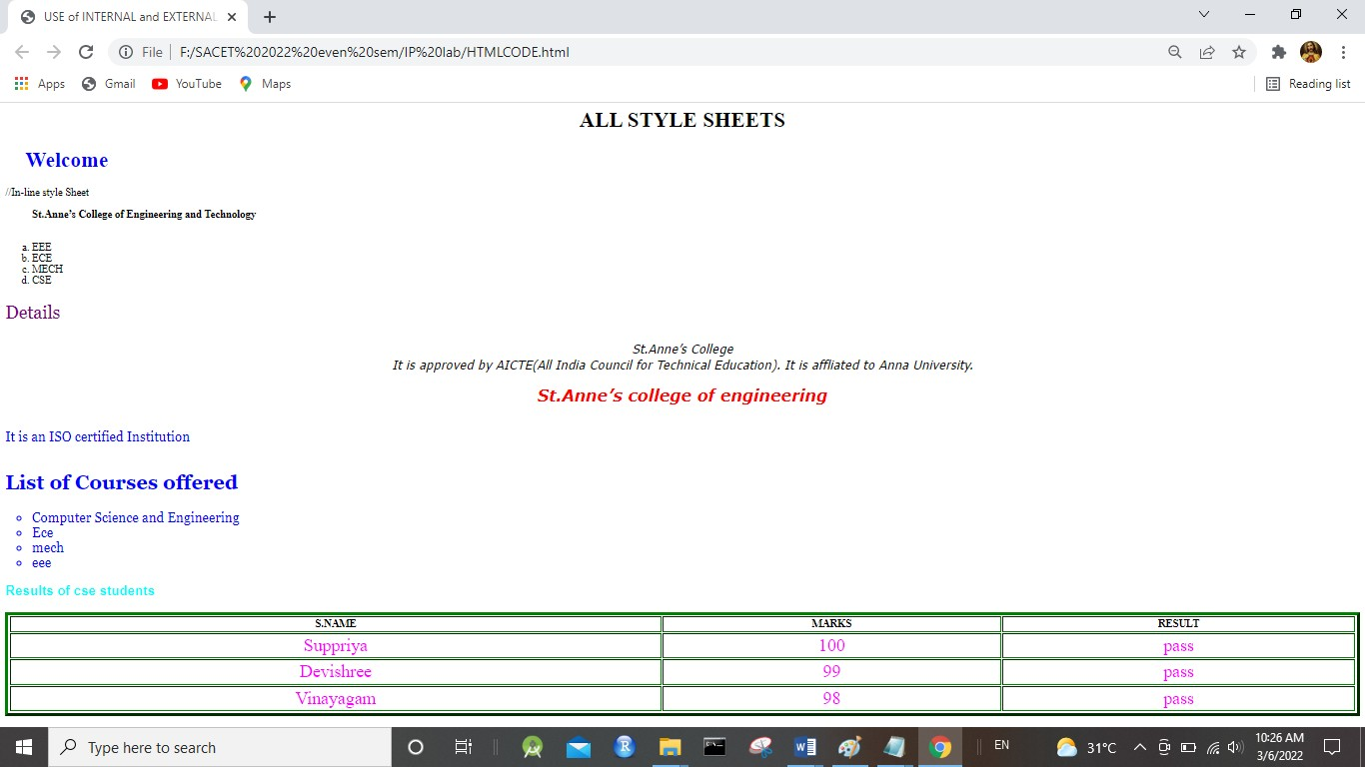

**EXPERIMENT-3**

### Name of the Experiment

### VALIDATION USING JAVASCRIPT

### Objective

To Validate the Registration, user login, user profile and payment by credit card pages using JavaScript.

### PROCEDURE:

1. Static web pages of an online Book store is developed with following pages.
   * Home page
   * Registration and user Login
   * User profile page
   * Books catalog
   * Payment by credit card
2. Each input box in webpage is validated using java script code using <script> tag in html file.
3. Designed output is displayed.

### Program

**Main.html:**

<html>

<head>

<title> ONLINE BOOK STORES</title>

</head>

<body bgcolor="pink">

<marquee><h1 align=”center”><b><u><font color="white"> ONLINE BOOK STORAGE</u></font>

</b></h1></marquee>

<H2 ALIGN="CENTER">

<b><p><U><FONT COLOR="PURPLE">Welcome to online book storage.

Press login if you are having id otherwise press registration.</U></FONT></p></b></H2>

<H2> <FONT COLOR="WHITE"></FONT></H2>

<H3 ALIGN="CENTER">

<A HREF="reg.html"><BR><BR><FONT COLOR="black"><ITALIC>REGISTRATION FORM</FONT></ITALIC><BR><BR>

<BR><BR><A HREF="profile.html"><FONT COLOR="black"><ITALIC>USER PROFILE</FONT></ITALIC><BR>

<BR><BR><A HREF="login.html"><FONT COLOR="black"><ITALIC>USER LOGIN</FONT></ITALIC><BR>

<BR><BR><A HREF="catalog.html"><FONT COLOR="black"><ITALIC>BOOKS CATALOG</FONT></ITALIC><BR>

<BR><BR><A HREF="payment.html"><FONT COLOR="black"><ITALIC>PAYMENT</FONT></ITALIC><BR>

<BR><BR><A HREF="Order.html"><FONT COLOR="black"><ITALIC>ORDER CONFIRMATION</H3></FONT></ITALIC><BR>

</body>

</html>

**Login.html:**

<html>

<body bgcolor=”blue”><br><br><br>

<script language=”javascript”> function validate()

{

var flag=1; if(document.myform.id.value==""||document.myform.pwd.value=="")

{

alert("LoginId and Password must be filled") flag=0;

}

if(flag==1)

{

alert(“VALID INPUT”);

window.open("catalog.html","right");

}

else

{

alert(“INVALID INPUT”);

//document.myform.focus();

}

}

</script>

<form name=”myform”>

<div align=”center”><pre>

LOGIN ID:<input type=”text” name=”id”><br> PASSWORD:<input type=”password” name=”pwd”>

<br><br>

</pre>

<input type=”button” value=”ok” onClick=”validate()”>

<input type=”reset” value=”clear”>

</div>

</form>

</body>

</html>

**Reg.html:**

<html>

<body bgcolor=”blue”><br><br>

<script language=”javascript”>

var str=document.myform.phno.value; var x;

if(flag==1)

{

}

else

{

}

}

alert("VALID INPUT");

alert("INVALID INPUT");

document.myform.focus();

</script>

<form name="myform">

<div align="center"><pre>

NAME :<input type="text" name="name"><br> ADDRESS :<input type="type" name="addr"><br>

CONTACT NUMBER:<iput type="text" name="phno"><br> LOGINID :<input type="text" name="id"><br>

PASSWORD :<input type="password" name="pwd"></pre><br><br>

</div>

<br><br>

<div align="center">

<input type="submit" value="ok" onClick="validate()">&nbsp;&nbsp;&nbsp;

<input type="reset" value="clear">

</form></body></html>

**Catalog.html:**

<html>

<body bgcolor="pink"><br><br><br>

<div align="center">

<pre>

BOOK TITLE:<input type="text" name="title"><br>

</pre><br><br>

</div>

<br><br>

<div align="center">

<input type="submit" value="ok" name="button1">

<input type="reset" value="clear" name="button2">

</body>

</html>

**Order.html:**

<html>

<body bgcolor="pink"><br><br><br>

<div align="center"><pre>

LOGIN ID :<input type="text" name="id"><br> TITLE :<input type="text" name="title"><br>

NO.OF BOOKS :<input type="text" name="no"><br> COST OF BOOK:<input type="text"name="cost"><br>

DATE :<input tpe="text" name="date"><br></pre><br><br>

</div>

<br><br>

<div align="center">

<input type="submit" value="ok" name="button1">

<input type="reset" value="clear" name="button2">

</body>

</html>

**Payment.html:**

<html>

<body bgcolor="pink"><br><br><br>

<script language="javascript"> function validate()

{

var flag=1; if(document.myform.id.value==""|| document.myform.pwd.value==""|| document.myform.amount.value==""|| document.myform.num.value=="")

{

flag=0;

}

var str=document.myform.amount.value; var x;

for(var i=0;i<str.length;i++)

{

x=str.substr(i,1); if(!(x<=9))

{

flag=0; break;

}

}

str=document.myform.num.value; for(var i=0;i<str.lenght;i++)

{

x=str.substr(i,1); if(!(x<=9))

{

flag=0; break;

}

}

if(flag==1)

{

}

else

{

}

}

alert("VALID INPUT");

alert("INVALID INPUT");

document.myform.focus();

</script>

<form name="myform">

<div align="center"><pre>

LOGIN ID :<input type="text" name="id"><br> PASSWORD :<input type="password" name="pwd"><br> AMOUNT :<input type="text" name="amount"><br>

CREDITCARDNUMBER:<input type="PASSWORD" name="num+"><br></pre><br><br>

</div>

<br><br><div align="center">

<input type="submit" value="ok" onClick="validate()">

<input type="reset" value="clear">

</form>

</body>

</html>

**Profile.html:**

<html>

<body bgcolor="pink"><br><br><br>

<script type="text/javascript"> function validate()

{

var flag=1; if(document.myform.id.value==""|| document.myform.pwd.value=="")

{

flag=0;

}

if(flag==1)

{

}

else

{

}

}

alert("VALID INPUT");

alert("INVALID INPUT");

document.myform.focus();

</script><form name="myform">

<div align="center"><pre>LOGIN ID :<input type="text" name="id"><br>

PASSWORD:<input type="password" name="pwd"></pre><br><br>

</div>

<br><br>

<div align="center">

<input type="submit" value="ok" onClick="validate()">

<input type="reset" value="clear" >

</form>

</body></html>

### LAB VIVA QUESTIONS

### What is java script?

### Is java script Object oriented or object based programming language?

### Explain HTML controls?

### Who invented java script?

### What are the applications of Java script?

### INPUT& OUTPUT :

### 

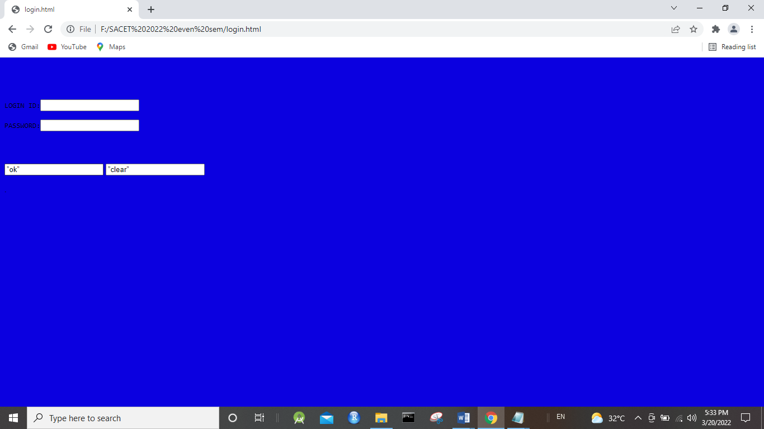

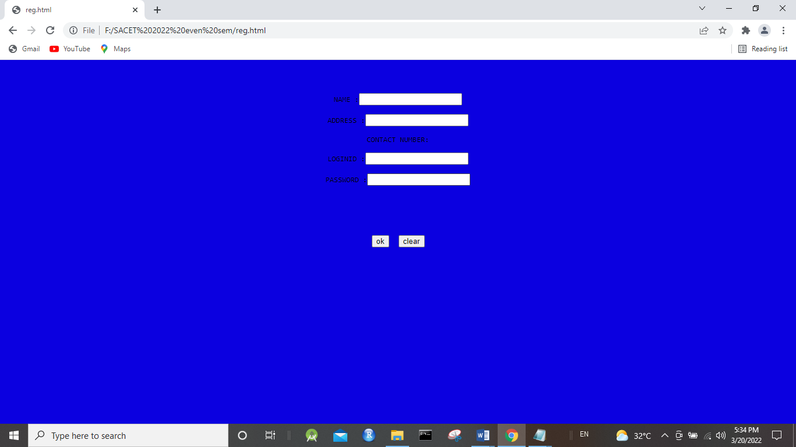

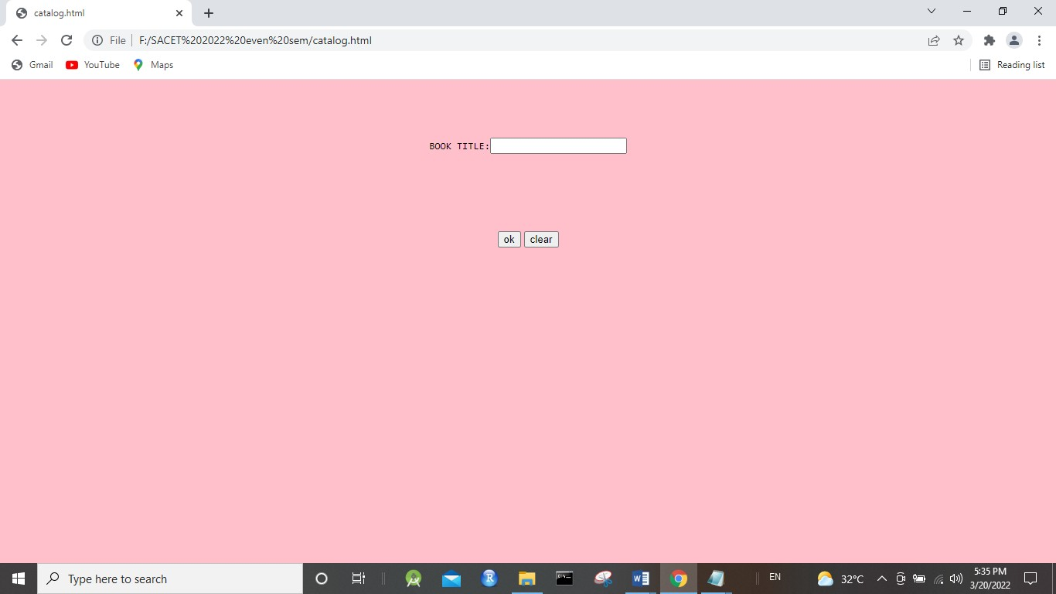

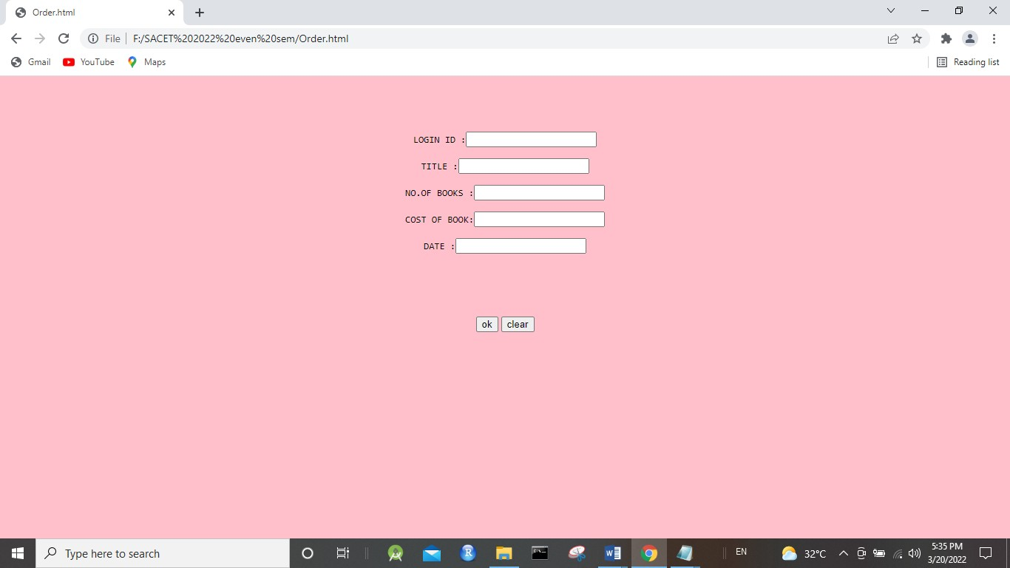

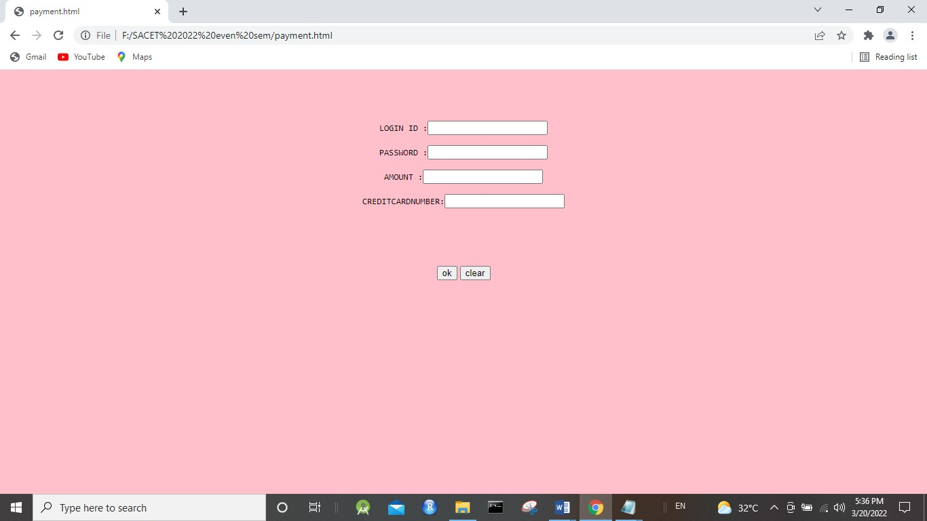

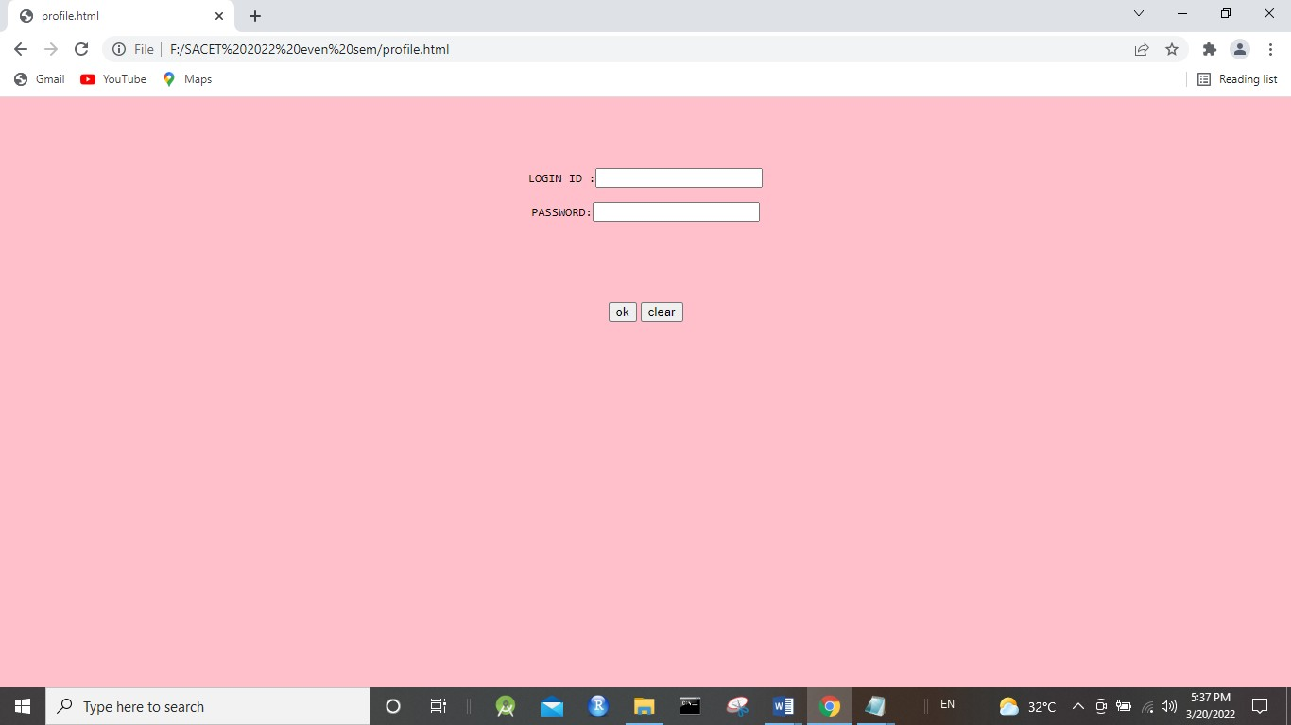

**EXPERIMENT-4**

### Name of the Experiment

### (4) (a) INVOKING SERVLETS FROM HTML FORM

### (4) (b) SESSION TRACKING USING HIDDEN FORM FIELDS

### (4) (c) SESSION TRACKING A HIT COUNT

### Objective

4 (a) To write a java program to invoke servlets from HTML form.

### PROCEDURE:

#### **client.html:**

1. Create a web page using HTML form that contains the fields such as text, password and one submit button.
2. Set the URL of the server as the value of form’s action attribute.
3. Run the HTML program.
4. Submit the form data to the server.

#### **server.java:**

1. Define the class server that extends the property of the class HttpServlet
2. Handle the request from the client by using the method service() of HttpServlet class.
3. Get the parameter names from the HTML form by using the method getParameterNames().
4. Get the parameter values from the HTML forms by using the method getParameter().
5. Send the response to the client by using the method of PrintWriter class.

4 (b) To write a Java Program for Session Tracking Using Hidden Form Fields. This servlet demonstrates session tracking using hidden form fields by displaying the shopping cart for a bookworm. Note that, if you try this servlet, the buttons at the bottom of the page it generates don't take you anywhere real.

### PROCEDURE:

* 1. Create a web page using HTML form that contains the fields such as text, password and one submit button.
  2. Set the URL of the server as the value of form’s action attribute.
  3. Ask if the user wants to add more items or check out.
  4. Include the current items as hidden fields so they'll be passed on and submit to self.

(4) (c) To write a Java Program for Session tracking a hit count. This servlet uses session tracking to count the number of times a client has accessed it.

PROCEDURE:

Get the current session object, create one if necessary

Increment the hit count for this page. The value is saved in this client's session under the name "tracker.count".

Display the hit count for this page

### Program (4) (a)

**MySrv.java:**

import java.io.IOException;

import java.io.PrintWriter;

import javax.servlet.ServletException;

import javax.servlet.http.HttpServlet;

import javax.servlet.http.HttpServletRequest;

import javax.servlet.http.HttpServletResponse;

public class MySrv extends HttpServlet {

public void doPost(HttpServletRequest request, HttpServletResponse response) throws ServletException, IOException {

response.setContentType("text/html");

PrintWriter out = response.getWriter();

out.println("<!DOCTYPE HTML PUBLIC \"-//W3C//DTD HTML 4.01

Transitional//EN\">"); out.println("<HTML>");

out.println(" <HEAD><TITLE>A Servlet</TITLE></HEAD>"); out.println(" <BODY>");

//Getting HTML parameters from Servlet

String username=request.getParameter("uname"); String password=request.getParameter("pwd");

if((username.equals("user")) && (password.equals("pswd")))

{

out.println(" <h1> Welcome to "+username);

}

else

{

out.println(" <h1> Registration success ");

out.println(" <a href='./index.html'> Click for Home page </a>");

}

out.println(" </BODY>"); out.println("</HTML>"); out.close();

}

public void doGet(HttpServletRequest request, HttpServletResponse response) throws ServletException, IOException {

doPost( request,response);

}

}

**Registration.html:**

<!DOCTYPE HTML PUBLIC "-//W3C//DTD HTML 4.0 Transitional//EN">

<HTML>

<HEAD>

<TITLE> New Document </TITLE>

<META NAME="Generator" CONTENT="EditPlus">

<META NAME="Author" CONTENT="">

<META NAME="Keywords" CONTENT="">

<META NAME="Description" CONTENT="">

</HEAD>

<BODY bgcolor='#e600e6'>

<form action='./MySrv' method="post">

<center> <h1> <u> Login Page </u></h1>

<h2> Username : <input type="text" name="uname"/> Password : <input type="password" name="pwd"/>

<input type="submit" value="click me"/>

</center></form></body></HTML>

**web.xml:**

<web-app>

<servlet>

<servlet-name>MySrv</servlet-name>

<servlet-class>MySrv</servlet-class>

</servlet>

<servlet-mapping>

<servlet-name>MySrv</servlet-name>

<url-pattern>/MySrv</url-pattern>

</servlet-mapping>

<welcome-file-list>

<welcome-file>index.html</welcome-file>

</welcome-file-list>

</web-app>

**Program (4) (b)**

**register.html:**

<html>

<body bgcolor = "cyan">

<center>

<h1>WELCOME TO REGISTRATION PAGE</h1>

<form action="./registerone" METHOD="post"> Name: <input type="text" name = "name"><br><br>

Password: <input type="password" name="password"><br><br> PROFESSION:

<select name="profession">

<option value="engineer">ENGINEER</option>

<option value="teacher">TEACHER</option>

<option value="businessman">BUSINESSMAN</option>

</select><br><br>

<input type="submit" value="REGISTER">

</form>

</center></body>

</html>

**web.xml**

<web-app>

<welcome-file-list>

<welcome-file>register.html</welcome-file>

</welcome-file-list>

<servlet>

<servlet-name>RegistrationServletOne</servlet-name>

<servlet-class>RegistrationServletOne</servlet-class>

</servlet>

<servlet-mapping>

<servlet-name>RegistrationServletOne</servlet-name>

<url-pattern>/registerone</url-pattern>

</servlet-mapping>

<servlet>

<servlet-name>RegistrationServletTwo</servlet-name>

<servlet-class>RegistrationServletTwo</servlet-class>

</servlet>

<servlet-mapping>

<servlet-name>RegistrationServletTwo</servlet-name>

<url-pattern>/registertwo</url-pattern>

</servlet-mapping>

</web-app>

**RegistrationServletOne.java:**

import java.io.IOException;

import java.io.PrintWriter;

import javax.servlet.ServletException;

import javax.servlet.http.HttpServlet;

import javax.servlet.http.HttpServletRequest;

import javax.servlet.http.HttpServletResponse;

public class RegistrationServletOne extends HttpServlet

{

public void doPost(HttpServletRequest request, HttpServletResponse response) throws ServletException, IOException

{

String name = request.getParameter("name");

String password = request.getParameter("password");

String profession = request.getParameter("profession"); response.setContentType("text/html");

PrintWriter out = response.getWriter();

out.println("<html><body bgcolor = wheat>");

out.println("<center>");

out.println("<h1>COMPLETE THE REGISTRATION</h1>");

out.println("<form action = ./registertwo method = post");

out.println("<input type = hidden name = name value =" + name + ">");

out.println("<input type = hidden name = password value =" + password + ">"); out.println("<input type = hidden name = profession value =" + profession + ">"); out.println("EMAIL ID:<input type =text name = email><br><br>"); out.println("PHONE NO:<input type =text name = cell><br><br>"); out.println("<input type =submit value=registernow>");

out.println("</center>");

out.println("</body></html>");

out.close();

}

}

**RegistrationServletTwo.java**

import java.io.IOException;

import java.io.PrintWriter;

import javax.servlet.ServletException;

import javax.servlet.http.HttpServlet;

import javax.servlet.http.HttpServletRequest;

import javax.servlet.http.HttpServletResponse;

public class RegistrationServletTwo extends HttpServlet

{

public void doPost(HttpServletRequest request, HttpServletResponse response) throws ServletException, IOException

{

String name = request.getParameter("name");

String password = request.getParameter("password");

String profession = request.getParameter("profession");

String email = request.getParameter("email");

String cell = request.getParameter("cell");

response.setContentType("text/html");

PrintWriter out = response.getWriter();

out.println("<html><body bgcolor = wheat>");

out.println("<center>");

out.println("<h1>REGISTRATION SUCCESSFUL </h1>");

out.println("</center>"); out.println("</body></html>");

out.close();

}

**Program (4) (c)**

**PageHitCounter.java**

import java.io.*;

import java.sql.Date;

import java.util.*;

import javax.servlet.*;

import javax.servlet.http.*;

public class PageHitCounter extends HttpServlet {

private int hitCount;

public void init() {

// Reset hit counter. hitCount = 0;

}

public void doGet(HttpServletRequest request, HttpServletResponse response) throws ServletException, IOException {

// Set response content type response.setContentType("text/html");

// This method executes whenever the servlet is hit

// increment hitCount hitCount++;

PrintWriter out = response.getWriter(); String title = "Total Number of Hits";

String docType = "<!doctype html public \"-//w3c//dtd html 4.0 " + "transitional//en\">\n";

out.println(docType + "<html>\n" +

"<head><title>" + title + "</title></head>\n" + "<body bgcolor = \"#f0f0f0\">\n" +

"<h1 align = \"center\">" + title + "</h1>\n" + "<h2 align = \"center\">" + hitCount + "</h2>\n" +

"</body>

</html>"

);

}

public void destroy() {

// This is optional step but if you like you

// can write hitCount value in your database.

}

}

**Web.xml**

<servlet>

<servlet-name>PageHitCounter</servlet-name>

<servlet-class>PageHitCounter</servlet-class>

</servlet>

<servlet-mapping>

<servlet-name>PageHitCounter</servlet-name>

<url-pattern>/PageHitCounter</url-pattern>

</servlet-mapping

### LAB VIVA QUESTIONS

### What is servlet?

### What are advantages of servlet?

### What are disadvantages of servlet?

### Explain architecture of servlet?

### Discuss life cycle of servlet?

### INPUT& OUTPUT : (4) (a)

### INPUT& OUTPUT : (4) (b)

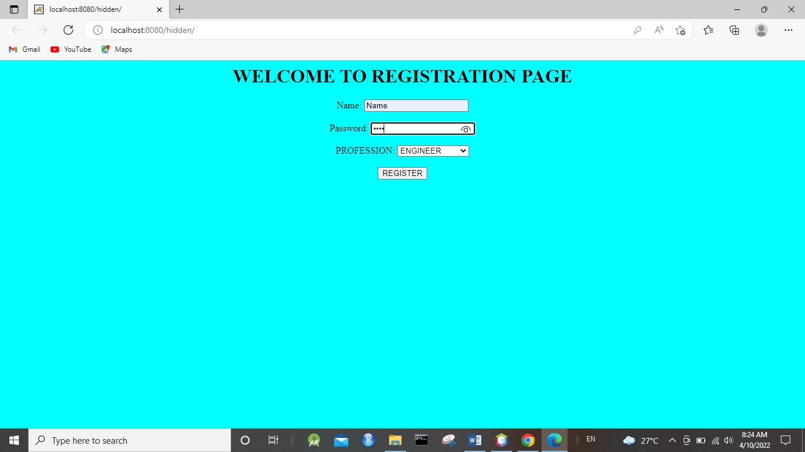

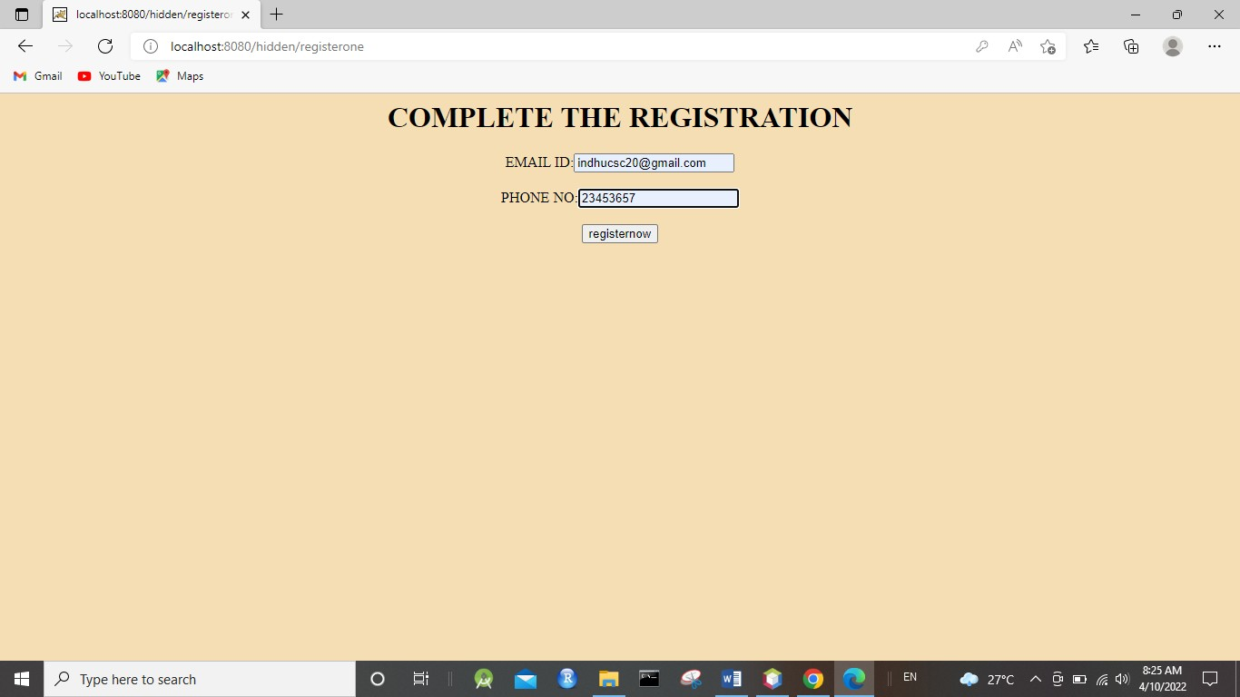

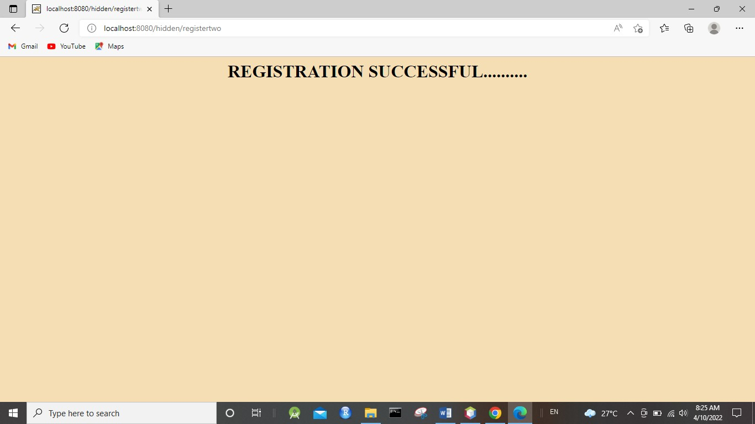

### INPUT& OUTPUT : (4) (c)

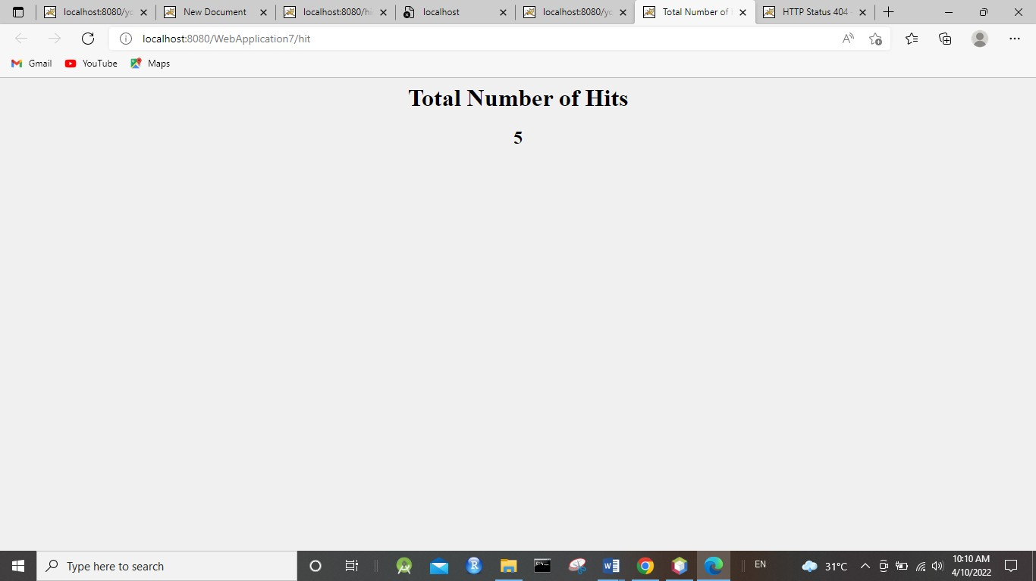

**EXPERIMENT-5**

### Name of the Experiment

### ON-LINE EXAMINATION USING SERVLETS

### Objective

To write java servlet programs to conduct online examination and to display student mark list available in a database

### PROCEDURE:

**Client:**

1. In index.html on the client side declare the contents that you like to transfer to the server using html form and input type tags.
2. Create a submit button and close all the included tags.

### Server:

1. Import all necessary packages
2. Define a class that extends servlet
3. In the doPost() method, do the following:
   1. Set the content type of the response to "text/html"
   2. Create a writer to the response
   3. Get a paratmeter from the request
   4. If its value is equal to right answer then add 5 to mark variable
   5. Similarly repeat step
   6. for all parameters
   7. Display the result in an html format using the writer

### Student Mark List Database:

1. Import necessary to java packages and javax packages and classes
2. Create a class that extends HttpServlet and implements ServletException
3. and IOException
4. In the doGet() method, do the following:
   1. Create a PrintWriter object
   2. Open a connection with the data source name
   3. Write a sql query and execute to get the resultset

### Display the resultset information in html form

### Program

### Servlet Code:

### import java.io.*; import java.sql.*; import javax.servlet.*;

### import javax.servlet.http.*;

### public class StudentServlet3 extends HttpServlet

### {

### String message,Seat_no,Name,ans1,ans2,ans3,ans4,ans5; int Total=0; Connection connect; Statement stmt=null; ResultSet rs=null;

### public void doPost(HttpServletRequest request,HttpServletResponse response) throws ServletExcep- tion,IOException

### {

### try

### {

### String url="jdbc:odbc:NEO"; Class.forName("sun.jdbc.odbc.JdbcOdbcDriver"); connect=DriverManager.getConnection(url," "," "); message="Thank you for participating in online Exam";

### }

### catch(ClassNotFoundException cnfex){ cnfex.printStackTrace();

### }

### catch(SQLException sqlex){ sqlex.printStackTrace();

### }

### catch(Exception excp){ excp.printStackTrace();

### }

### Seat_no=request.getParameter("Seat_no"); Name=request.getParameter("Name"); ans1=request.getParameter("group1"); ans2=request.getParameter("group2"); ans3=request.getParameter("group3"); ans4=request.getParameter("group4"); ans5=request.getParameter("group5"); if(ans1.equals("True"))

### Total+=2; if(ans2.equals("False")) Total+=2; if(ans3.equals("True")) Total+=2; if(ans4.equals("False")) Total+=2; if(ans5.equals("False")) Total+=2; try

### {

### Statement stmt=connect.createStatement();

### String query="INSERT INTO student("+"Seat_no,Name,Total"+") VAL- UES('"+Seat_no+"','"+Name+"','"+Total+"')";

### int result=stmt.executeUpdate(query); stmt.close();

### }catch(SQLException ex){

### }

### response.setContentType("text/html"); PrintWriter out=response.getWriter(); out.println("<html>"); out.println("<head>"); out.println("</head>"); out.println("<body bgcolor=cyan>"); out.println("<center>"); out.println("<h1>"+message+"</h1>\n");

### out.println("<h3>Yours results stored in our database</h3>"); out.print("<br><br>"); out.println("<b>"+"Participants and their Marks"+"</b>"); out.println("<table border=5>"); try

### {

### Statement stmt=connect.createStatement(); String query="SELECT * FROM student"; rs=stmt.executeQuery(query); out.println("<th>"+"Seat_no"+"</th>"); out.println("<th>"+"Name"+"</th>"); out.println("<th>"+"Marks"+"</th>"); while(rs.next())

### {

### out.println("<tr>"); out.print("<td>"+rs.getInt(1)+"</td>"); out.print("<td>"+rs.getString(2)+"</td>"); out.print("<td>"+rs.getString(3)+"</td>"); out.println("</tr>");

### }

### out.println("</table>");

### }

### catch(SQLException ex){ } finally

### {

### try

### {

### if(rs!=null) rs.close(); if(stmt!=null) stmt.close(); if(connect!=null)

### connect.close();

### }

### catch(SQLException e){ }

### }

### out.println("</center>"); out.println("</body></html>"); Total=0;

### } }

### HTML Code:

### <html><head><title>Database Test</title></head> <body>

### <center><h1>Online Examination</h1> </center>

### <form action="StudentServlet3.view" method="POST"> <div align="left"><br></div>

### <b>Seat Number:</b> <input type="text" name="Seat_no"> <div align="Right">

### <b>Name:</b> <input type="text" name="Name" size="50"><br> </div>

### <br><br>

### <b>1. Every host implements transport layer.</b><br/> <input type="radio" name="group1" value="True">True <input type="radio" name="group1" value="False">False<br>

### <b>2. It is a network layer's responsibility to forward packets reliably from source to destina- tion</b><br/>

### <input type="radio" name="group2" value="True">True

### <input type="radio" name="group2" value="False">False<br>

### <b>3. Packet switching is more useful in bursty traffic</b><br/> <input type="radio" name="group3" value="True">True<input type="radio" name="group3" value="False">False<br> <b>4. A phone network uses packet switching</b><br/> <input type="radio" name="group4" value="True">True

### <input type="radio" name="group4" value="False">False<br>

### <b>5. HTML is a Protocol for describing web contents</b><br/> <input type="radio" name="group5" value="True">True

### <input type="radio" name="group5" value="False">False<br> <br><br><br>

### <center>

### <input type="submit" value="Submit"><br><br> </center>

### </form></body></html>

### LAB VIVA QUESTIONS

### What is use of servlet?

### What are the applications of servlet?

### How servlet is used in developing web applications?

### What are the advantages of servlets over JSP?

### What is life cycle of servlet?

### INPUT& OUTPUT :

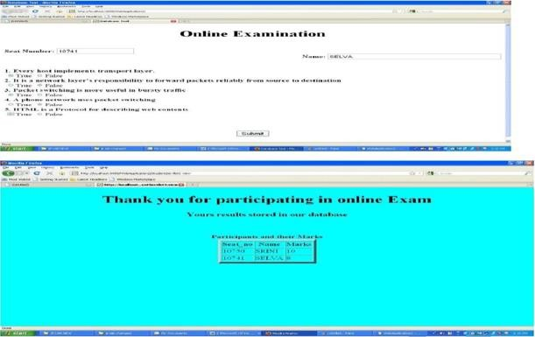

**EXPERIMENT-6**

### Name of the Experiment

### CONVERSION OF STATIC WEBPAGES INTO DYNAMIC USING SERVLETS

### Objective

To convert the static web pages into dynamic web pages using servlets (or JSP) and cookies.

### PROCEDURE:

1. We will create ahtml form for entering the user name,password and card ID.
2. From the above HTML form, the servlet program is invoked in which the validity of the user name,password and card id is checked.if it is a valid user then the welcome message will be displayed otherwise the “invalid user” message will be displayed. In this servlet we set the cookies in which the current user name is stored.
3. Compile the above servlet Login servlet.java and copy its class file in tomcats folder at c:\tomcatdirectory\webapps\examples\WEB-INF\classes.
4. Then edit the web.xml in WEB-INF folder.We must store he user information such as user name,password and card id in the web.xml using init-param.
5. On successful login , the information from the cookie is checked and shopping cart page for corressponding user can be displayed.
6. Compile the above servlet LoginSuccess.java and copy its class file in the tomcat's folder at c:\tomcatdirectory\webapps\examples\WEB-INF\classes.
7. Then edit the web.xml in WEB-INF folder.
8. Start tomcat web server.Open the web browser and display the login form created in step1.

### Program

### Loginform.html

### <!DOCTYPE html>

### <html>

### <head>

### <body>

### <form action="http://localhost:8080/shopping/LoginServlet" method="post">

### Enter username:

### <input type="text" value="" name="User"><br><br> enter password:

### <input type="password" value="" name="password"><br><br> enter card ID:

### <input type="text" value="" name="CardID"><br><br>

### <input type="submit" value="login">

### </form>

### </body>

### </html>

### LoginServlet.java

### package shopping;

### import java.io.*;

### import javax.servlet.*;

### import javax.servlet.http.*;

### public class LoginServlet extends HttpServlet

### {

### protected void doPost(HttpServletRequest req, HttpServletResponse res) throws ServletException,IOException

### 

### {

### res.setContentType("text/html");

### PrintWriter out=res.getWriter();

### String usr=req.getParameter("User");

### String pwd=req.getParameter("password");

### String card=req.getParameter("CardID");

### boolean flag=true;

### String[] userID=getInitParameter("usernames").split(",");

### String[] password=getInitParameter("passwords").split(",");

### String[] cardids=getInitParameter("cardIDs").split(",");

### int i;

### for(i=0;i<userID.length;i++)

### {

### if(userID[i].equals(usr) && password[i].equals(pwd)&&cardids[i].equals(card))

### {

### flag=false;

### Cookie cookie1=new Cookie("CurrentUser",usr);

### Cookie cookie2=new Cookie("CreditCard",card);

### res.addCookie(cookie1);

### res.addCookie(cookie2);

### out.println("<h2>Welcome "+usr+"</h2><hr>");

### out.println("<h2>Select the book you would like to purchase<h2><hr>");

### out.println("<form action='LoginSuccess'>");

### out.println("<input type=radio name='book' checked value='Let us C'/>Let us C<br>");

### out.println("<input type=radio name='book' value='Exploring Python'/>Exploring Python<br>");

### out.println("<input type=radio name='book' value='Mastering C'/>Mastering C<br>"); out.println("<input type=submit value='purchase'><hr>");

### }

### }

### if(flag==true)

### {

### out.println("<h4>Invalid user name or password or card number,please try again by clicking following link</h4>");

### out.println("<a href='LoginForm.html'>"+"LoginForm.html");

### }

### }

### }

### LoginSuccess.java

### package shopping;

### import java.io.*;

### import javax.servlet.*;

### import javax.servlet.http.*;

### public class LoginSuccess extends HttpServlet

### {

### protected void doGet(HttpServletRequest req,HttpServletResponse res) throws ServletException,IOException

### {

### Cookie[] mycookie=req.getCookies();

### res.setContentType("text/html");

### PrintWriter out=res.getWriter();

### String book=req.getParameter("book");

### out.print("<h2>welcome "+mycookie[0].getValue()+"</h2><hr>");

### out.print("<h3>Thank you for purchasing book:"+book+"</h3><hr>"); out.print("<h3>Rs.250 debited from credit card: "+mycookie[1].getValue()); out.close();

### }

### }

### Web.xml

### <?xml version="1.0" encoding="UTF-8"?>

### <web-app version="3.1" xmlns="http://xmlns.jcp.org/xml/ns/javaee" xmlns:xsi="http://www.w3.org/2001/XMLSchema-instance" xsi:schemaLocation="http://xmlns.jcp.org/xml/ns/javaee http://xmlns.jcp.org/xml/ns/javaee/web- app_3_1.xsd">

### <servlet>

### <init-param>

### <param-name>usernames</param-name>

### <param-value> indhu,abc,xyz</param-value>

### </init-param>

### <init-param>

### <param-name>passwords</param-name>

### <param-value>indhu,abc,xyz</param-value>

### </init-param>

### <init-param>

### <param-name>cardIDs</param-name>

### <param-value>111111,222222,333333</param-value>

### </init-param>

### <servlet-name>LoginServlet</servlet-name>

### <servlet-class>shopping.LoginServlet</servlet-class>

### </servlet>

### <servlet-mapping>

### <servlet-name>LoginServlet</servlet-name>

### <url-pattern>/LoginServlet</url-pattern>

### </servlet-mapping>

### <servlet>

### <servlet-name>LoginSuccess</servlet-name>

### <servlet-class>shopping.LoginSuccess</servlet-class>

### </servlet>

### <servlet-mapping>

### <servlet-name>LoginSuccess</servlet-name>

### <url-pattern>/LoginSuccess</url-pattern>

### </servlet-mapping>

### </web-app>

### LAB VIVA QUESTIONS

1. What is a static web page?
2. What is a Dynamic web page?
3. Differentiate between static and dynamic web pages?
4. Which pages are called interactive pages?
5. What is the use of interactive web pages?

### INPUT& OUTPUT :

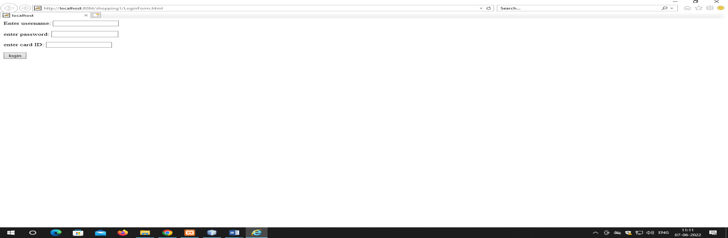

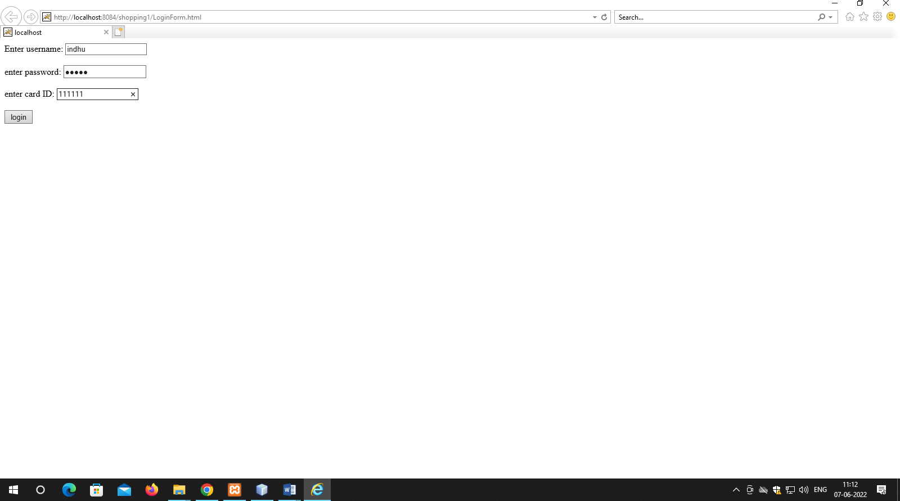

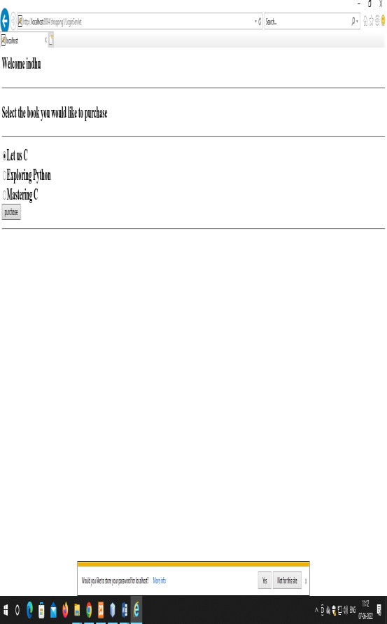 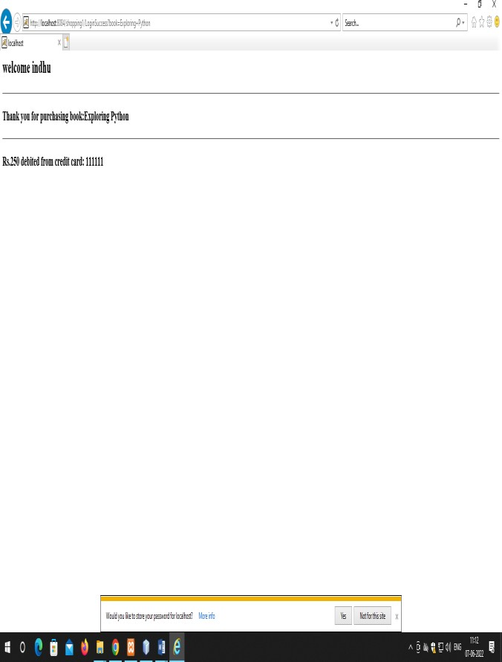

**EXPERIMENT-7**

### Name of the Experiment

### CONVERSION OF STATIC WEBPAGES INTO DYNAMIC USING JSP

### Objective

To convert the static web pages into dynamic web pages using JSP. Create a database with user information and books information. The books catalogue should be dynamically loaded from the database.

### PROCEDURE:

1. Create your own directory under tomcat/webapps (e.g. tr1).
2. Copy the html files in tr1.
3. Copy the jsp files also into tr1.
4. Start tomcat give the following command.
   1. Catalina.bat run
   2. At install‐dir/bin
5. At I.E give url as http://localhost:8081/tr1/main.html.

### Program

### Main.html:

### <html>

### <body bgcolor=”pink”>

### <br><br><br><br><br><br>

### <h1 align=”center”>>U>ONLINE BOOK STORAGE</u></h1><br><br><br>

### <h2 align=”center”><PRE>

### <b> Welcome to online book storage. Press LOGIN if you are having id Otherwise press REGISTRATION

### </b></PRE></h2>

### <br><br><pre>

### <div align=”center”><a href=”/tr/login.html”>LOGIN</a> href=”/tr/login.html”>REGISTRATION</a></div></pre>

### </body></html>

### Login.html:

### <html>

### <body bgcolor=”pink”><br><br><br>

### <form name="myform" method="post" action=/tr1/login.jsp">

### <div align="center"><pre>

### LOGIN ID : <input type="passwors" name="pwd"></pre><br><br> PASSWORD : <input type="password" name="pwd"></pre><br><br>

### </div>

### <br><br>

### <div align="center">

### <inputtype="submit"value="ok" onClick="validate()">&nbsp;&nbsp;&nbsp;&nbsp;&nbsp;<input type="reset"

### value="clear">

### </form>

### </body>

### </html>

### Reg.html:

### <html>

### <body bgcolor="pink"><br><br>

### <form name="myform" method="post" action="/tr1/reg.jsp">

### <div align="center"><pre>

### NAME :<input type="text" name="name"><br> ADDRESS :<input type="text" name="addr"><br>

### CONTACT NUMBER : <input type="text" name="phno"><br> LOGIN ID : <input type="text" name="id"><br>

### PASSWORD : <input type="password" name="pwd"></pre><br><br>

### </div>

### <br><br>

### <div align="center">

### <inputtype="submit"value="ok" onClick="validate()">()">&nbsp;&nbsp;&nbsp;&nbsp;&nbsp;<input type="reset" value="clear">

### </form>

### </body>

### </html>

### Profile.html:

### <html>

### <body bgcolor="pink"><br><br>

### <form name="myform" method="post" action="/tr1/profile.jsp">

### <div align="center"><pre>

### LOGIN ID : <input type="text" name="id"><br>

### </pre><br><br>

### </div>

### <br><br>

### <div align="center">

### <inputtype="submit"value="ok" onClick="validate()">()">&nbsp;&nbsp;&nbsp;&nbsp;&nbsp;<input type="reset" value="clear">

### </form>

### </body>

### </html>

### Catalog.html:

### <html>

### <body bgcolor="pink"><br><br><br>

### <form method="post" action="/tr1/catalog.jsp">

### <div align="center"><pre>

### BOOK TITLE : <input type="text" name="title"><br>

### </pre><br><br>

### </div>

### <br><br>

### <div align="center">

### <inputtype="submit"value="ok" name=”button1”>&nbsp;&nbsp;&nbsp;&nbsp;&nbsp;<inputtype="reset"value="clear" name=”button2”>

### </form>

### </body>

### </html>

### Order.html:

### <html>

### <body bgcolor="pink"><br><br><br>

### <form method="post" action="/tr1/order.jsp">

### <div align="center"><pre>

### LOGIN ID :<input type="text" name="id"><br> PASSWORD : <input type="password" name="pwd"><br> TITLE :<input type="text" name="title"><br>

### NO. OF BOOKS : <input type="text" name="no"><br> DATE : <input type="text" name="date"><br>

### CREDIT CARD NUMBER : <input type="password" name="cno"><br></pre><br><br>

### </div>

### <br><br>

### <div align="center">

### <input type="submit" value="ok" name=”button1”>&nbsp;&nbsp;&nbsp;&nbsp;&nbsp;<input type="reset"

### value="clear" name=”button2”>

### </form>

### </body>

### </html>

### Login.jsp:

### %@page import=”java.sql.*”%

### %@page import=”java.io.*”%

### <%

### out.println(“<html><body bgcolor=\”pink\”>”);

### String id=request.getParameter(“id”);

### String pwd=request.getParameter(“pwd”);

### Driver d=new oracle.jdbc.driver.OracleDriver();

### DriverManager.registerDriver(d);

### Connection con=DriverManager.getConnection(“jdbc:oracle:thin:@localhost:1521:orcl”,”scott”,”tiger”);

### Statement stmt=con.createStatement();

### String sqlstmt=”select id,password from login where id=”+id+” and password=”+pwd+””;

### ResultSet rs=stmt.executeQuery(sqlstmt);

### int flag=0;

### while(rs.next())

### {

### flag=1;

### }

### if(flag==0)

### {

### out.println(“SORRY INVALID ID TRY AGAIN ID<br><br>”);

### out.println(“ <a href=\”/tr1/login.html\”>press LOGIN to RETRY</a>”);

### }

### else

### {

### out.println(“VALID LOGIN ID<br><br>”);

### out.println(“<h3><ul>”);

### out.println(“<li><ahref=\”profile.html\”><fontcolor=\”black\”>USER PROFILE</font></a></li><br><br>”);

### out.println(“<li><ahref=\”catalog.html\”><fontcolor=\”black\”>BOOKS CATALOG</font></a></li><br><br>”); out.println(“<li><ahref=\”order.html\”><fontcolor=\”black\”>ORDER CONFIRMATION</font></a></li><br><br>”);

### out.println(“</ul>”);

### }

### out.println(“<body></html>”);

### %>

### Reg.jsp:

### %@page import=”java.sql.*”%

### %@page import=”java.io.*”%

### <%

### out.println(“<html><body bgcolor=\”pink\”>”);

### String name=request.getParameter(“name”);

### String addr=request.getParameter(“addr”);

### String phno=request.getParameter(“phno”);

### String id=request.getParameter(“id”);

### String pwd=request.getParameter(“pwd”);

### int no=Integer.parseInt(phno);

### Driver d=new oracle.jdbc.driver.OracleDriver();

### DriverManager.registerDriver(d);

### Connection con= DriverManager.getConnection (“jdbc:oracle:thin:@localhost:1521:orcl”,”scott”,”tiger”);

### Statement stmt=con.createStatement();

### String sqlstmt=”select id from login”;

### ResultSet rs=stmt.executeQuery(sqlstmt);

### int flag=0;

### while(rs.next())

### {

### if(id.equals(rs.getString(1)))

### {

### flag=1;

### }

### }

### if(flag==1)

### {

### out.println(“SORRY LOGIN ID ALREADY EXISTS TRY AGAIN WITH NEW ID <br><br>”);

### out.println(“<a href=\”/tr1/reg.html\”>press REGISTER to RETRY</a>”);

### }

### else

### {

### Statement stmt1=con.createStatement ();

### stmt1.executeUpdate (“insert into login values (“+name+”,”+addr+”,”+no+”,”+id+”,”+pwd+”)”);

### out.println (“YOU DETAILS ARE ENTERED <br><br>”);

### out.println (“<a href =\”/tr1/login.html\”>press LOGIN to login</a>”);

### }

### out.println (“</body></html>”);

### %>

### Profile.jsp:

### <%@page import=”java.sql.*”%>

### <%@page import=”java.io.*”%>

### <%

### out.println (“<html><body bgcolor=\”pink\”>”);

### String id=request.getParameter(“id”);

### Driver d=new oracle.jdbc.driver.OracleDriver();

### DriverManager.regiserDriver(d);

### Connection con= DriverManager.getConnection (“jdbc:oracle:thin:@localhost:1521:orcl”,”scott”,”tiger”);

### Statement stmt=con.createStatement ();

### String sqlstmt=”select * from login where id=”+id+””;

### ResultSet rs=stmt.executeQuery (sqlstmt);

### int flag=0;

### while(rs.next())

### {

### out.println (“<div align=\”center\”>”);

### out.println (“NAME :”+rs.getString(1)+”<br>”);

### out.println (“ADDRESS :”+rs.getString(2)+”<br>”);

### out.println (“PHONE NO :”+rs.getString(3)+”<br>”);

### out.println (“</div>”);

### flag=1;

### }

### if(flag==0)

### {

### out.println(“SORRY INVALID ID TRY AGAIN ID <br><br>”);

### out.println(“<a href=\”/tr1/profile.html\”>press HERE to RETRY </a>”);

### }

### out.println (“</body></html>”);

### %>

### Catalog.jsp:

### <%@page import=”java.sql.*”%>

### <%@page import=”java.io.*”%>

### <%

### out.println (“<html><body bgcolor=\”pink\”>”);

### String title=request.getParameter (“title”);

### Driver d=new oracle.jdbc.driver.OracleDriver ();

### DriverManager.regiserDriver (d);

### Connection con= DriverManager.getConnection (“jdbc:oracle:thin:@localhost:1521:orcl”,”scott”,”tiger”);

### Statement stmt=con.createStatement ();

### String sqlstmt=”select * from book where title=”+title+””;

### ResultSet rs=stmt.executeQuery (sqlstmt);

### int flag=0; while(rs.next())

### {

### out.println (“<div align=\”center\”>”);

### out.println (“TITLE :”+rs.getString(1)+”<br>”);

### out.println (“AUTHOR :”+rs.getString(2)+”<br>”);

### out.println (“VERSION:”+rs.getString(3)+”<br>”);

### out.println (“PUBLISHER :” +rs.getString(4)+”<br>”);

### out.println (“COST :” +rs.getString(5)+”<br>”);

### out.println (“</div>”);

### flag=1;

### }

### if(flag==0)

### {

### out.println(“SORRY INVALID ID TRY AGAIN ID <br><br>”);

### out.println(“<a href=\”/tr1/catalog.html\”>press HERE to RETRY </a>”);

### }

### out.println (“</body></html>”);

### %>

### Order.jsp:

### <%@page import=”java.sql.*”%>

### <%@page import=”java.io.*”%>

### <%

### out.println (“<html><body bgcolor=\”pink\”>”);

### String id=request.getParameter (“id”);

### String pwd=request.getParameter (“pwd”);

### String title=request.getParameter (“title”);

### String count1=request.getParameter (“no”);

### String date=request.getParameter (“date”);

### String cno=request.getParameter (“cno”);

### int count=Integer.parseInt(count1);

### Driver d=new oracle.jdbc.driver.OracleDriver ();

### DriverManager.regiserDriver (d);

### Connection con=

### DriverManager.getConnection (“jdbc:oracle:thin:@localhost:1521:orcl”,”scott”,”tiger”); Statement stmt=con.createStatement ();

### String sqlstmt=”select id, password from login”;

### ResultSet rs=stmt.executeQuery (sqlstmt);

### int flag=0,amount,x;

### while(rs.next())

### {

### if(id.equals(rs.getString(1))&& pwd.equals(rs.getString(2)))

### {

### flag=1;

### }

### }

### if(flag==0)

### {

### out.println(“SORRY INVALID ID TRY AGAIN ID <br><br>”);

### out.println(“<a href=\”/tr1/order.html\”>press HERE to RETRY </a>”);

### }

### else

### {

### Statement stmt2=con.createStatement();

### String s=”select cost from book where title=”+title+””;

### ResultSet rs1=stmt2.executeQuery(s);

### int flag1=0; while(rs1.next())

### {

### flag1=1;

### x=Integer.parseInt(rs1.getString(1));

### amount=count*x;

### out.println(“AMOUNT :”+amount+”<br><br><br><br>”);

### Statement stmt1=con.createStatement ();

### stmt1.executeUpdate (“insert into details (“+id+”,”+title+”,”+amount+”,”+date+”,”+cno+”)”);

### out.println (“YOU ORDER HAS TAKEN<br>”);

### }

### if(flag1==0)

### {

### out.println(“SORRY INVALID BOOK TRY AGAIN <br><br>”);

### out.println(“<a href=\”/tr1/order.html\”>press HERE to RETRY </a>”);

### }

### }

### out.println (“</body></html>”);%>

### LAB VIVA QUESTIONS

1. What is JSP?
2. What is shopping cart?
3. What is a database?
4. What is a static web page?
5. What is dynamic web page>
6. What is meant by book catalogue?

### INPUT& OUTPUT :

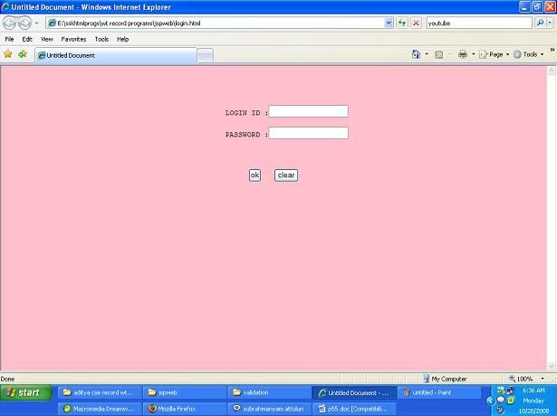

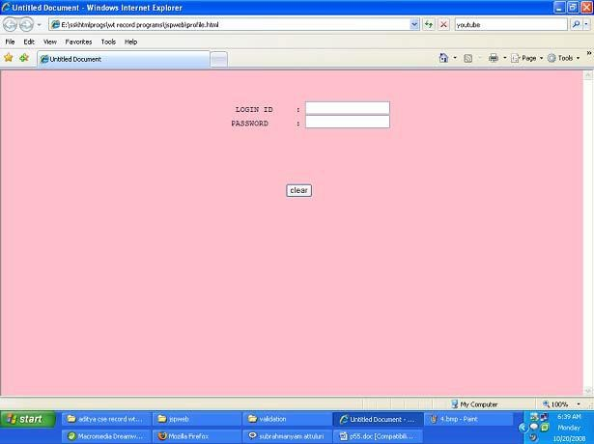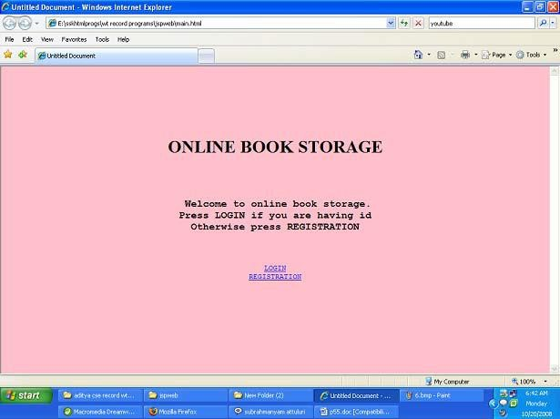

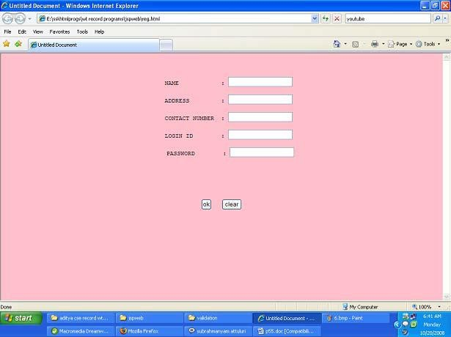

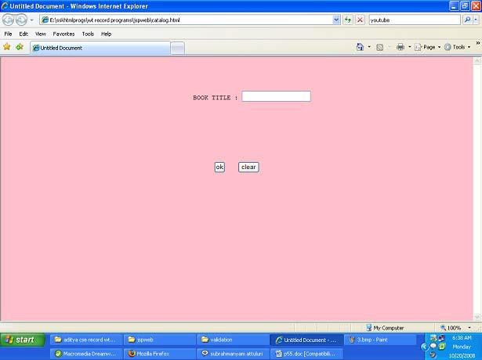 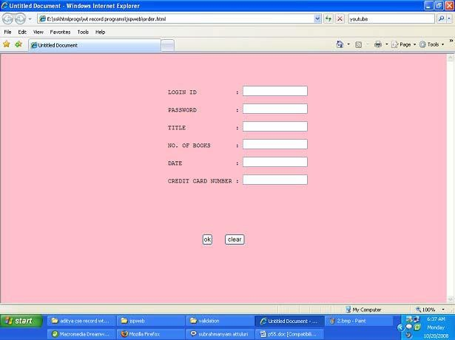

**EXPERIMENT-8**

### Name of the Experiment

### CREATION OF XML DOCUMENT

### Objective

To create and save an XML document at the server, which contain some users information.

To develop Java Program takes user id as an input and returns the user details by taking the user information from the XML document.

### PROCEDURE:

1. Save Students information in the XML file on the specific location.
2. Create and Establish the server connection between html file and XML file in the host
3. Get the user ID as input
4. Display the user’s information.

### Program

### index.html:

### <!DOCTYPE html>

### <HTML>

### <HEAD>

### <TITLE>Searching for XML Elements </TITLE>

### <SCRIPT>

### function readXMLData()

### {

### var xmlDocumentObject, id , name, addr, phone, email;

### xmlDocumentObject=new XMLHttpRequest();

### xmlDocumentObject.open("GET","userlist.xml",false);

### xmlDocumentObject.send();

### xmlDocumentObject=xmlDocumentObject.responseXML;

### id = xmlDocumentObject.getElementsByTagName("userid");

### name = xmlDocumentObject.getElementsByTagName("username");

### address = xmlDocumentObject.getElementsByTagName("address");

### phone = xmlDocumentObject.getElementsByTagName("phone");

### email = xmlDocumentObject.getElementsByTagName("email");

### for (i = 0; i < id.length; i++)

### {

### output=id[i].firstChild.nodeValue;

### if (output == document.getElementById("myText").value)

### {displayDIV.innerHTML = id[i].firstChild.nodeValue + "<br> " + name[i].firstChild.nodeValue

### +"<br> " +address[i].firstChild.nodeValue + "<br> " + phone[i].firstChild.nodeValue+"<br>"+email[i].firstChild.nodeValue;

### } } }

### </SCRIPT>

### </HEAD>

### <BODY>

### <H1>Search User</H1>

### <input type="text" id="myText" value="">

### <input type="BUTTON" VALUE="Get User Details" ONCLICK="readXMLData()">

### <P>

### <DIV ID="displayDIV"> </DIV>

### </BODY>

### </HTML>

### 

### userlist.xml:

### <userlist>

### <userid>usr01</userid>

### <username>indhu</username>

### <address>trichy</address>

### <phone>9000000078</phone>

### <email>indhu@gmail.com</email>

### <userid>usr02</userid>

### <username>Pooja</username>

### <address>chennai</address>

### <phone>9111111111</phone>

### <email>pooja@gmail.com</email>

### <userid>usr03</userid>

### <username>sadhana</username>

### <address>telugana</address>

### <phone>9222222222</phone>

### <email>sadhana@gmail.com</email>

### <userid>usr04</userid>

### <username>sameera</username>

### <address>bangalore</address>

### <phone>9555555555</phone>

### <email>sameera@gmail.com</email>

### <userid>usr05</userid>

### <username>naveena</username>

### <address>Perambalur</address>

### <phone>9666666666</phone>

### <email>naveena@gmail.com</email>

### </userlist>

### LAB VIVA QUESTIONS

1. What is XML?
2. What is DTD?
3. What are the applications of XML?
4. How to create XMLHttpRequest Object?
5. Why XML?
6. How XML is different from HTML?
7. What is the meaning of version in XML?
8. What are the benefits of XML?
9. What is XML DOM?
10. What is SAX in XML?
11. What is a well formed XML document?
12. What is a valid XML document?

### INPUT& OUTPUT :

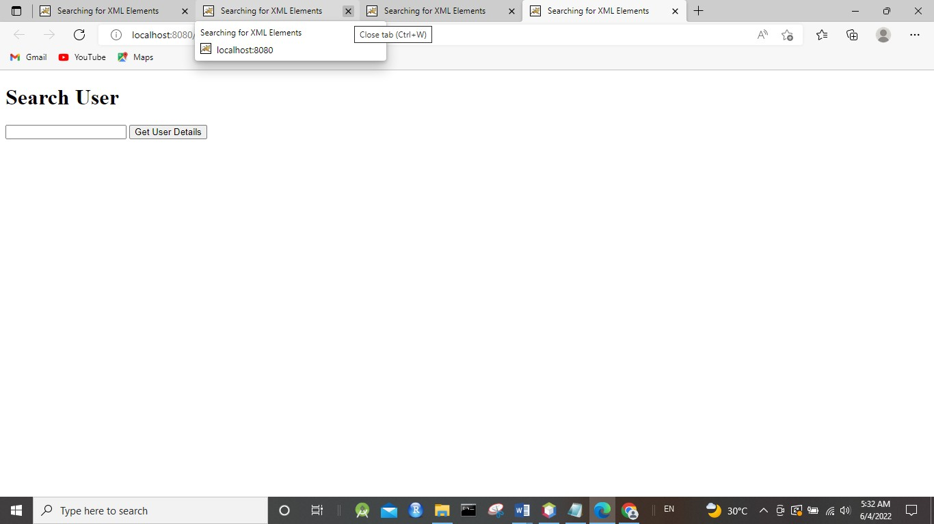

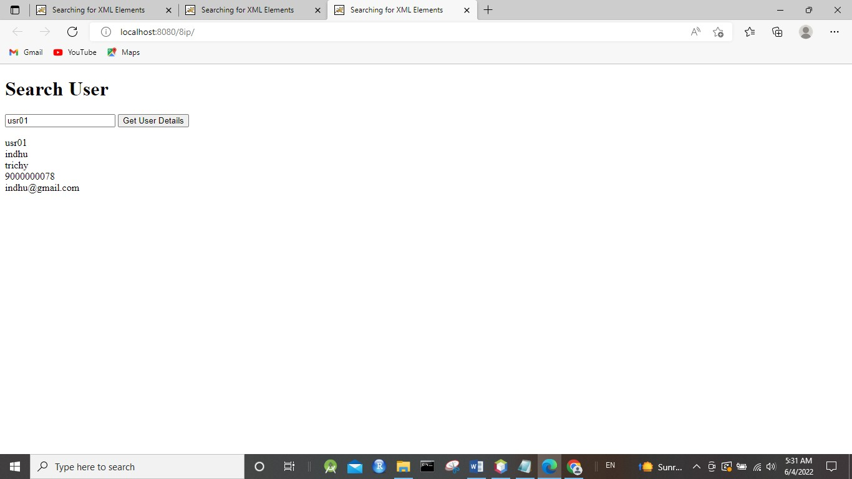

**EXPERIMENT-9**

### Name of the Experiment

### (9) (a) FORM VALIDATION USING PHP REGULAR EXPRESSION

### (9) (b) STORING A FORM DATA IN PHP

### Objective

(9)(a) To validate the form using PHP regular expression.

### PROCEDURE:

1. Form is created for class registration with fileds.
2. These fields are validated using PHP code.
3. Form is displayed.

(9)(b) To store a PHP form data into database.

### PROCEDURE:

1. Form is created with fileds name, mail id, contact and address.
2. Table is created in mysql.
3. The input data entered into the fields are stored using PHP code.

### Program (9) (a)

### index.php:

### <!DOCTYPE HTML>

### <html>

### <head>

### <style>

### .error {color: #FF0000;}

### </style>

### </head>

### <body>

### <?php

### $nameErr = $emailErr = $genderErr = $websiteErr = "";

### $name = $email = $gender = $comment = $website = ""; if ($_SERVER["REQUEST_METHOD"] == "POST") {

### if (empty($_POST["name"])) {

### $nameErr = "Name is required";

### } else {

### $name = test_input($_POST["name"]);

### if (!preg_match("/^[a-zA-Z-' ]*$/",$name)) {

### $nameErr = "Only letters and white space allowed";

### }

### }

### if (empty($_POST["email"])) {

### $emailErr = "Email is required";

### } else {

### $email = test_input($_POST["email"]);

### if (!filter_var($email, FILTER_VALIDATE_EMAIL)) {

### $emailErr = "Invalid email format";

### }

### }

### if (empty($_POST["website"])) {

### $website = "";

### } else {

### $website = test_input($_POST["website"]);

### 

### if (!preg_match("/\b(?:(?:https?|ftp):\/\/|www\.)[-a-z0-9+&@#\/%?=~_|!:,.;]*[-a-z0- 9+&@#\/%=~_|]/i",$website)) {

### $websiteErr = "Invalid URL";

### }

### }

### if (empty($_POST["comment"])) {

### $comment = "";

### } else {

### $comment = test_input($_POST["comment"]);

### }

### if (empty($_POST["gender"])) {

### $genderErr = "Gender is required";

### } else {

### $gender = test_input($_POST["gender"]);

### }}

### function test_input($data) {

### $data = trim($data);

### $data = stripslashes($data);

### $data = htmlspecialchars($data); return $data;

### }

### ?>

### <h2>PHP Form Validation Example</h2>

### <p><span class="error">* required field</span></p>

### <form method="post" action="<?php echo htmlspecialchars($_SERVER["PHP_SELF"]);?>">

### Name: <input type="text" name="name" value="<?php echo $name;?>">

### <span class="error">* <?php echo $nameErr;?></span>

### <br><br>

### E-mail: <input type="text" name="email" value="<?php echo $email;?>">

### <span class="error">* <?php echo $emailErr;?></span>

### <br><br>

### Website: <input type="text" name="website" value="<?php echo $website;?>">

### <span class="error"><?php echo $websiteErr;?></span>

### <br><br>

### Comment: <textarea name="comment" rows="5" cols="40"><?php echo

### $comment;?></textarea>

### <br><br> Gender:

### <input type="radio" name="gender"

### <?php if (isset($gender) &&

### $gender=="female") echo "checked";?> value="female">Female

### <input type="radio" name="gender"

### <?php if (isset($gender) && $gender=="male") echo "checked";?> value="male">Male

### <input type="radio" name="gender"

### <?php if (isset($gender) && $gender=="other") echo "checked";?> value="other">Other

### <span class="error">*

### <?php echo $genderErr;?></span>

### <br><br>

### <input type="submit" name="submit" value="Submit">

### </form>

### <?php

### echo "<h2>Your Input:</h2>"; echo $name;

### echo "<br>"; echo $email; echo "<br>"; echo $website; echo "<br>"; echo $comment; echo "<br>"; echo $gender;

### ?>

### </body>

### </html>

### Program (9)(b)

### index.php:

### <!DOCTYPE html>

### <html>

### <head>

### <style>

### .error {color: #FF0000;}

### </style>

### </head>

### <body>

### <?php

### $nameErr = $emailErr = $genderErr = $websiteErr = "";

### $name = $email = $gender = $comment = $website =$result= ""; if ($_SERVER["REQUEST_METHOD"] == "POST") {

### if (empty($_POST["name"])) {

### $nameErr = "Name is required";

### } else {

### $name = test_input($_POST["name"]);

### if (!preg_match("/^[a-zA-Z ]*$/",$name)) {

### $nameErr = "Only letters and white space allowed";

### }

### }

### 

### if (empty($_POST["email"])) {

### $emailErr = "Email is required";

### } else {

### $email = test_input($_POST["email"]);

### if (!filter_var($email, FILTER_VALIDATE_EMAIL)) {

### $emailErr = "Invalid email format";

### }

### }

### if (empty($_POST["website"])) {

### $website = "";

### } else {

### $website = test_input($_POST["website"]);

### if (!preg_match("/\b(?:(?:https?|ftp):\/\/|www\.)[-a-z0-9+&@#\/%?=~_|!:,.;]*[-a-z0- 9+&@#\/%=~_|]/i",$website)) {

### $websiteErr = "Invalid URL";

### }

### }

### if (empty($_POST["comment"])) {

### $comment = "";

### } else {

### $comment = test_input($_POST["comment"]);

### }

### if (empty($_POST["gender"])) {

### $genderErr = "Gender is required";

### } else {

### $gender = test_input($_POST["gender"]);

### }

### $servername = "localhost";

### 

### $username = "root";

### $password = "";

### $dbname = "iplab";

### $conn = new mysqli($servername, $username, $password, $dbname); if ($conn->connect_error) {

### die("Connection failed: " . $conn->connect_error);

### }

### $sql = "INSERT INTO register (name, email,website,comments,gender) VALUES ('$name', '$email', '$website','$comment', '$gender')";

### if ($conn->query($sql) === TRUE) {

### $result="New Record Inserted Successfully";

### } else {

### echo "Error: " . $sql . "<br>" . $conn->error;

### }

### $conn->close();

### }

### function test_input($data) {

### $data = trim($data);

### $data = stripslashes($data);

### $data = htmlspecialchars($data); return $data;

### }

### ?>

### <h2>Registration Form</h2>

### <p><span class="error">* required field</span></p>

### <form method="post" action="<?php echo htmlspecialchars($_SERVER["PHP_SELF"]);?>"> Name: <input type="text" name="name">

### 

### <span class="error">* <?php echo $nameErr;?></span>

### <br><br>

### E-mail: <input type="text" name="email">

### <span class="error">* <?php echo $emailErr;?></span>

### <br><br>

### Website: <input type="text" name="website">

### <span class="error"><?php echo $websiteErr;?></span>

### <br><br>

### Comment: <textarea name="comment" rows="5" cols="40"></textarea>

### <br><br> Gender:

### <input type="radio" name="gender" value="female">Female

### <input type="radio" name="gender" value="male">Male

### <span class="error">* <?php echo $genderErr;?></span>

### <br><br>

### <input type="submit" name="submit" value="Submit">

### </form>

### <?php

### echo $result;

### ?>

### </body>

### </html>

### LAB VIVA QUESTIONS

### What is a regular expression?

### What is PHP?

### What is use of Regular Expressions?

### What is the mean of Regular Expressions?

### What the mean of different symbols like ^ $ in Regular Expression?

### Write a Regular expression to match line that doesn't contain a word?

### How do I remove all non alphanumeric characters from a string?

### Write a Simple regular expression for a decimal with a precision of 2?

### **What are Advantages and uses of Regular expressions?**

### **What are different Operators in Regular Expression?**

### **What are the Special Character Classes in Regular Expressions?**

### INPUT& OUTPUT : (9)(a)

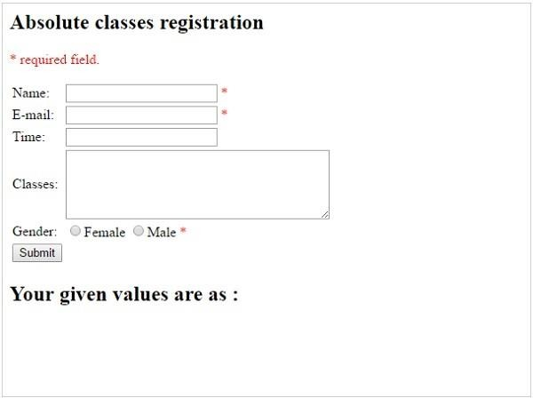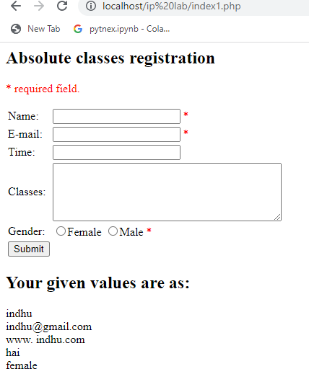

### INPUT& OUTPUT : (9)(b)

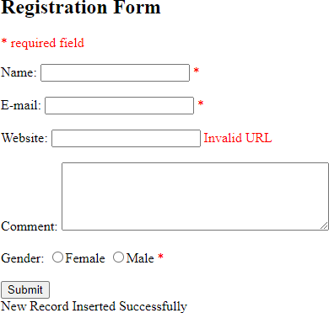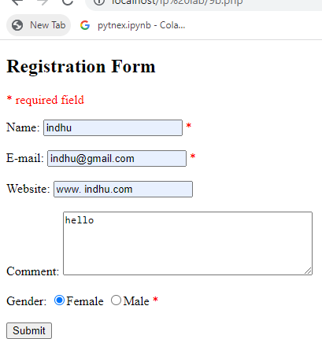

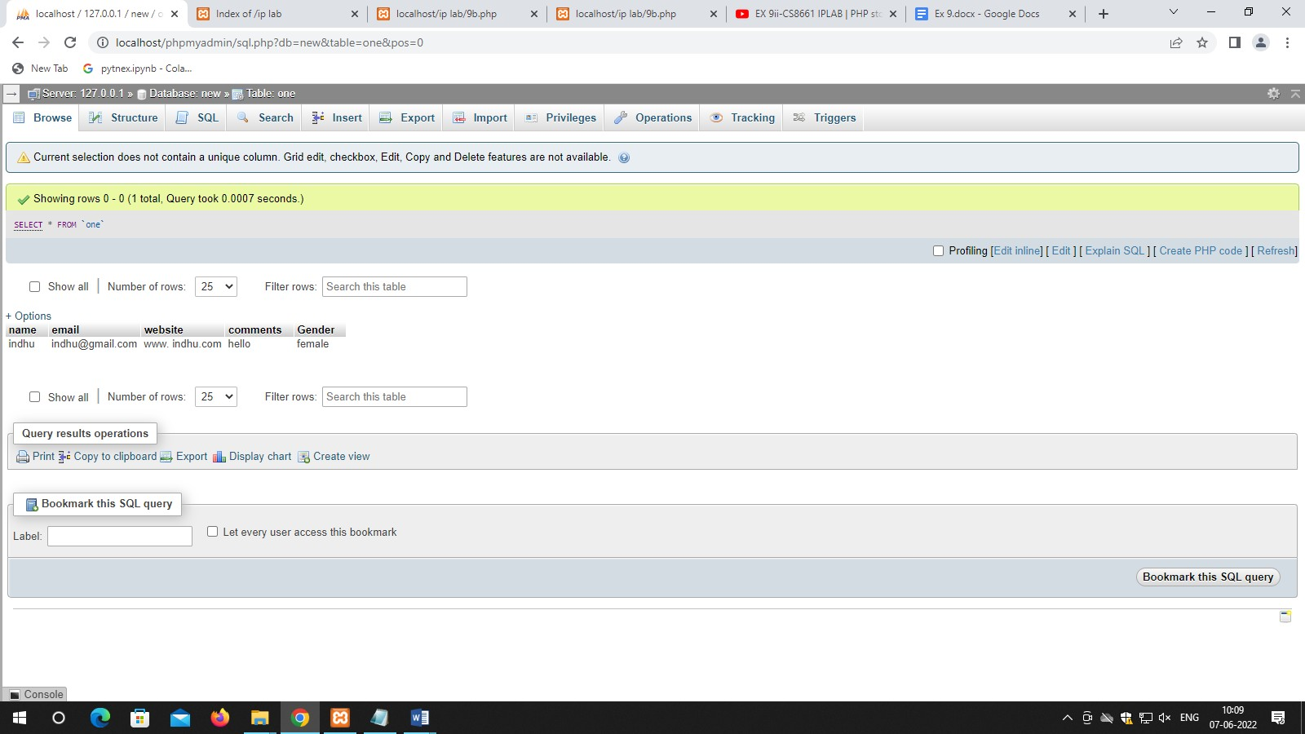

**EXPERIMENT-10**

### Name of the Experiment

### WEB SERVICE FOR FINDING PEOPLE’S OPINION

### Objective

To Write a web services for finding what people think by asking 500 people’s opinion for

any consumer product

### PROCEDURE:

* 1. Open the home page.
  2. Enter the login ID and type the comments then submit.
  3. Retrieve comments with post id
  4. Display the comments.

### Program

### Index.php

### <!doctype html>

### <html lang="en">

### <head>

### <meta charset="UTF-8" />

### <title>jQuery Ajax Comment System - Demo</title>

### <link rel="stylesheet" href="css/style.css">

### <script src="http://ajax.googleapis.com/ajax/libs/jquery/1.10.2/jquery.min.js"></script>

### <script src="js/script.js"></script>

### </head>

### <body>

### <div class="wrap">

### <h1> Maggy Noodles Comment System</h1>

### <?php

### ?>

### // retrive post include('config.php'); include ('function.php'); dbConnect();

### $query = mysql_query(

### 'SELECT *

### FROM post

### WHERE post_id = 1');

### $row = mysql_fetch_array($query);

### <div class="post">

### <h2><?php echo $row['post_title']?></h2>

### <p><?php echo $row['post_body']?></p>

### <?php

### </div>

### // retrive comments with post id

### $comment_query = mysql_query( "SELECT *

### FROM comment

### WHERE post_id = {$row['post_id']} ORDER BY comment_id DESC LIMIT 15");

### ?>

### <h2>Comments. </h2>

### <div class="comment-block">

### <?php while($comment = mysql_fetch_array($comment_query)): ?>

### <div class="comment-item">

### <div class="comment-avatar">

### <img src="<?php echo avatar($comment['mail']) ?>" alt="avatar">

### </div>

### <div class="comment-post">

### <h3><?php echo $comment['name'] ?> <span>said. </span></h3>

### <p><?php echo $comment['comment']?></p>

### </div>

### </div>

### <?php endwhile?>

### </div>

### <h2>Submit new comment</h2>

### <!--comment form -->

### <form id="form" method="post">

### <!-- need to supply post id with hidden fild -->

### <input type="hidden" name="postid" value="<?php echo $row['post_id']?>">

### <label>

### <span>Name *</span>

### <input type="text" name="name" id="comment-name" placeholder="Your name here " required>

### </label>

### <label>

### <span>Email *</span>

### <input type="email" name="mail" id="comment-mail" placeholder="Your mail here " required>

### </label>

### <label>

### <span>Your comment *</span>

### <textarea name="comment" id="comment" cols="30" rows="10" placeholder="Type your comment here " required></textarea>

### </label>

### <input type="submit" id="submit" value="Submit Comment">

### </form>

### </div>

### </body>

### </html>

### Ajax_Comment.php

### <?php

### if (isset( $_SERVER['HTTP_X_REQUESTED_WITH'] )):

### include('config.php'); include('function.php'); dbConnect();

### if (!empty($_POST['name']) AND !empty($_POST['mail']) AND

### !empty($_POST['comment']) AND !empty($_POST['postid'])) {

### $name = mysql_real_escape_string($_POST['name']);

### $mail = mysql_real_escape_string($_POST['mail']);

### $comment = mysql_real_escape_string($_POST['comment']);

### $postId = mysql_real_escape_string($_POST['postid']);

### mysql_query("

### INSERT INTO comment (name, mail, comment, post_id)

### VALUES('{$name}', '{$mail}', '{$comment}', '{$postId}')");

### }

### ?>

### <div class="comment-item">

### <div class="comment-avatar">

### <img src="<?php echo avatar($mail) ?>" alt="avatar">

### </div>

### <div class="comment-post">

### <h3><?php echo $name ?> <span>said. </span></h3>

### <p><?php echo $comment?></p>

### </div>

### <?php

### </div>

### dbConnect(0);

### endif?>

### Config.php

### <?php

### # db configuration define('DB_HOST', 'localhost'); define('DB_USER', 'root');

### define('DB_PASS', 'root'); define('DB_NAME', 'dbname');

### ?>

### Function.php

### <?php

### /**

### * Connect to mysql server

### * @param bool

### * @use true to connect false to close

### */

### function dbConnect($close=true){ if (!$close) {

### mysql_close($link); return true;

### }

### $link = mysql_connect(DB_HOST, DB_USER, DB_PASS) or die('Could not connect to MySQL DB ') . mysql_error();

### if (!mysql_select_db(DB_NAME, $link)) return false;

### }

### /**

### * gravatar Image

### * @see http://en.gravatar.com/site/implement/images/

### */

### function avatar($mail, $size = 60){

### $url = "http://www.gravatar.com/avatar/";

### $url .= md5( strtolower( trim( $mail ) ) );

### // $url .= "?d=" . urlencode( $default );

### $url .= "&s=" . $size; return $url;

### }

### ?>

### Style.CSS

### /* general styling */

### *{

### }

### body{

### }

### .wrap{

### }

### margin: 0;

### padding: 0;

### box-sizing: border-box;

### -webkit-box-sizing: border-box;

### -moz-box-sizing: border-box;

### -webkit-font-smoothing: antialiased;

### -moz-font-smoothing: antialiased;

### ont-smoothing: antialiased; font-smoothing: antialiased;

### text-rendering: optimizeLegibility;

### font: 12px Arial,Tahoma,Helvetica,FreeSans,sans-serif; text-transform: inherit;

### color: #333; background: #e7edee; width: 100%;

### text-shadow: 0 1px 1px rgba(0, 0, 0, 0.2)

### width: 720px; margin: 15px auto; padding: 15px 20px; background: white;

### border: 2px solid #DBDBDB;

### -webkit-border-radius: 5px;

### -moz-border-radius: 5px; border-radius: 5px; overflow: hidden;

### a{ text-decoration: none; color: #333} h1{

### font-family: Georgia, "Times New Roman", Times, serif; font-size: 2.8em;

### text-align: center; margin: 25px 0;

### }

### h2{font-size: 1.5em; margin: 8px 0} h3{

### font-size: 1.2em; margin: 5px 0;

### }

### h3 span{

### }

### .item{

### }

### font-weight: normal; font-size: 1em;

### clear: both; margin:0; padding: 10px; overflow: hidden;

### border-top: 1px solid #DBDBDB;

### .item:last-child{border-bottom:1px solid #DBDBDB}

### .item:hover{background: #f9f9f9}

### .post{

### padding: 10px 0;

### border-bottom: 1px solid #E6E6E6;

### }

### .comment-block{

### margin: 20px 0 20px 20px;

### }

### .comment-item{

### overflow: hidden; width: 500px; clear: both; padding: 10px;

### border: 1px solid #E6E6E6; border-radius: 5px;

### margin: 5px;

### }

### .comment-avatar{

### width: 60px; float: left;

### }

### .comment-avatar img{

### width: 60px; height: 60px; border-radius: 5px;

### }

### .comment-post{

### width: 400px; float: left;

### padding: 0 5px 0 10px;

### }

### #form{

### }

### clear: both; margin: 10px; width: 500px;

### /* form styling */ input[type="text"], input[type="email"], input[type="tel"], input[type="url"],

### textarea {

### width:100%; background: #fff; border: 1px solid #ddd; font-size: 13px;

### line-height: 20px; margin: 0; padding: 7px 10px;

### box-shadow: inset 0 1px 2px #eee; border:1px solid #CCC;

### margin:0 0 5px; border-radius:5px;

### }

### textarea {

### height:100px; max-width:100%;

### }

### input[type="submit"] {

### cursor:pointer; width:100%; border:none; background:#991D57;

### background-image:linear-gradient(bottom, #8C1C50 0%, #991D57 52%);

### background-image:-moz-linear-gradient(bottom, #8C1C50 0%, #991D57 52%);

### background-image:-webkit-linear-gradient(bottom, #8C1C50 0%, #991D57 52%); color:#FFF;

### margin:0 0 5px; padding:10px; border-radius:5px;

### }

### input[type="submit"]:hover {

### background-image:linear-gradient(bottom, #9C215A 0%, #A82767 52%);

### background-image:-moz-linear-gradient(bottom, #9C215A 0%, #A82767 52%);

### background-image:-webkit-linear-gradient(bottom, #9C215A 0%, #A82767 52%);

### -webkit-transition:background 0.3s ease-in-out;

### -moz-transition:background 0.3s ease-in-out; transition:background-color 0.3s ease-in-out;

### }

### input[type="submit"]:active {

### box-shadow:inset 0 1px 3px rgba(0,0,0,0.5);

### }

### input:focus, textarea:focus {

### outline:0;

### border:1px solid #999;

### }

### label{

### }

### display: block; margin: 5px 0;

### font-weight: 900; cursor: pointer;

### .alert{

### }

### display: none;

### padding: 8px 35px 8px 14px; margin: 20px 0;

### text-shadow: 0 1px 0 rgba(255, 255, 255, 0.5);

### color: #468847; background-color: #dff0d8; border-color: #d6e9c6;

### -webkit-border-radius: 4px;

### -moz-border-radius: 4px; border-radius: 4px;

### Script.js

### $(document).ready(function(){ var form = $('form');

### var submit = $('#submit');

### form.on('submit', function(e) {

### // prevent default action e.preventDefault();

### // send ajax request

### $.ajax({

### url: 'ajax_comment.php', type: 'POST',

### cache: false,

### data: form.serialize(), //form serizlize data beforeSend: function(){

### // change submit button value text and disabled it submit.val('Submitting...').attr('disabled', 'disabled');

### },

### success: function(data){

### // Append with fadeIn see http://stackoverflow.com/a/978731 var item = $(data).hide().fadeIn(800);

### $('.comment-block').append(item);

### // reset form and button form.trigger('reset');

### submit.val('Submit Comment').removeAttr('disabled');

### },

### error: function(e){

### alert(e);

### });

### });

### LAB VIVA QUESTIONS

### List some examples of web services.

### List out some web service technologies?

### What is SOAP?

### What is WSDL?

### What is UDDI?

### What is a web Service?

### INPUT& OUTPUT :

